Shut up don't 

***République Tunisienne***

***\*\*\*\*\****

***Ministère de l’Enseignement Supérieur et de la Recherche Scientifique***

***\*\*\*\*\****

***Université de Monastir***

***\*\*\*\*\****

***Institut Supérieur d’Informatique et de Mathématiques de Monastir***

***\*\*\*\*\****

***Départment Informatique***



**N° d’ordre :LA32**

Mémoire de Projet

De Fin d’Etudes

***Présenté en vue de l’obtention du***

Diplôme National de Licence Appliquée en Sciences Informatique

***Spécialité :***

Systèmes Informatique et Logiciel

***par***

***Rami Ferjani***

**Développement d’une application web dynamique pour le suivit et gestion des activités.**

***Soutenu le 07/02/2021 devant le jury composé de :***

|  |  |
| --- | --- |
| M./Mme : Mourad KMIMECH | Président |
| M./Mme : Maissa HAMOUDA | Rapporteur |
| M./Mme : Fakher BEN FTIMA | Encadrant Pédagogique |
| M./Mme :Kais JRAD | Encadrant Professionnel |
|  |  |

**Résumé**

Le Projet consiste a concevoir et développer une application web dynamique pour le suivi et gestion des activités sportifs pour le compte de la société Méga-DEV dans le cadre de l’obtention du Diplôme National de License Appliquée en Informatiques a l’institut Supérieure d’informatique et Mathématique de Monastir (ISIMM).

L’application permet à ses utilisateurs de recevoir un programme de remise en forme qui répond à ses objectifs, ainsi que de fournir des instructions quotidiennes concernant l'entraînement, elle connectera également les utilisateurs entre eux.

**Mots clés :** ReactJS, NodeJS, Express.JS, MongoDB, Socket.io

**Abstract**

The project consists of designing and developing a dynamic web application for the management of fitness activities for Meg-DEV company as part of obtaining the national diploma of Applied License in Computer Science at the Higher Institute of Computer Science and Mathematics of Monastir.

This application allows its user to receive a fitness program that meets their goals, as well as providing daily instructions concerning the workout, it will also connect users with each other.

Key words: ReactJS, NodeJS, Express.JS, MongoDB, Socket.io

Dedication

Thanks to Almighty **Allah**

who gave me the strength and patient to finish this work.

To my beloved parents **Samira and Ridha**

To raise me to believe that anything was possible. For always loving and supporting me,

without you none of my success would be possible.

For my sister, **Meriem** and my brother **Anis** You are my window to the world of childhood, the joy and gaiety in life that I see in you, your eternal love, give me hope for a better future for all of us.

**To all my friends:**

You have always supported and encouraged me during the years of this study.

Thanks for being always there for me.

**To all my family members:**

For the exceptional moments and unlimited care and support.

**Thanks**

Above all, I thank God, almighty, for all that he has given me in all that I have undertaken in my life so much courage and patience.

The realization of this work was possible thanks to the participation of several people to whom we would like to express our gratitude.

I thank Mr. Kais Jrad , the director of Mega-DEV, which eased my way through this project. Special thanks to Dr. Ben Ftima Fakher, who helped me complete this work and who agreed to supervise my internship and for their advice, which was very precious to me. Finally, I would like to thank all the teachers of the Higher Institute of Computer Science and Mathematics of Monastir, who constantly combine their efforts to provide us with solid training.

Finally, I thank the members of the jury, who will give my work value added through their recommendations and remarks so important, hoping they find in this report the qualities of clarity and motivation they expect, for which I will be very grateful.

Table of Contents

Chapter 1 : Context and Objectives 11

Introduction 11

1.1 Internship Context 11

1.2 Presentation of the host company 11

1.3 Motivation and problematic 12

1.4 Study of existing solution on the market 12

1.4.1 fitness Blender 12

1.4.2 BodyBuilding.com 15

1.5 Criticism of the existing solutions 19

1.6 Our solution 20

1.7 Methodologies 21

Chapter 2 Specifications and Conceptions 25

2.5 Identification of Actors 27

2.4.1 Global use-case diagram: 27

2.4.2 Authentication use-case diagram: 28

Conclusion 35

Chapter 3 Design and architecture 36

3.2.1 MVC MERN Stack 36

3.2.2 MVC Flow 38

3.4 Deployment Diagram 40

3.5 Logical Architecture 41

3.6 Sequence diagrams 44

3.5.1 Authentication Sequence Diagram 45

3.5.1 User Management Sequence Diagram 45

3.5.1 New Chat Sequence Diagram 46

3.6 General Class Diagram 47

3.7 Gantt Diagram 48

3.8 Conclusion 49

Chapter 4 : Realization 50

4.2 Working environment and tools 50

4.2.1 Material Environment 50

4.2.2 Software Environment 51

4.3 Implementation 57

4.3.1 Home Interface 57

4.3.2 Registration interface 58

4.3.3 Login Interface 59

4.3.4 Admin Dashboard interface 60

4.3.5 Create workout interface 62

4.3.6 Manage Workout Interface 63

4.3.7 Manage Workout Interface 63

4.3.8 Chat Interface 64

4.3.8 Create Group Chat Interface 65

4.3.8 Leaderboard Interface 65

4.3.9 Profile Interface 66

Conclusion 67

General conclusion and perspectives 68

Webography 69

Tables of Figures

Figure ‎1.1:Fitness Blender Home Page 14

Figure ‎1.2:Fitness Blender video page 14

Figure ‎1.3:Bodybuilding home page 16

Figure ‎1.4:Bodybuilding Body Fit page 16

Figure ‎1.5:weeksixpack Home Page 18

Figure ‎1.6:sixweeksixpac Home Page 18

Figure ‎1.7:Waterfall methodology diagram 22

Figure ‎1.8:Scrum Process Diagram 23

Figure ‎2.1:General use case diagram 28

Figure ‎2.2:Authentication use case diagram 29

Figure ‎2.3:Workout Management Use-Case Diagram 30

Figure ‎2.4:Chats Management Use Case Diagram 33

Figure ‎3.1:The Controller Figure ‎3.2:The View 37

Figure ‎3.3:The model 38

Figure ‎3.4:MVC flow 38

Figure ‎3.5:Physical Architecture 39

Figure ‎3.6:Deployment Diagram 40

Figure ‎3.7:Logical Architecture Diagram 41

Figure ‎3.8:BackEnd diagram 42

Figure ‎3.9:Redux diagram 43

Figure ‎3.10:Socket.io Diagram 44

Figure ‎3.11:Authentication Sequence Diagram 45

Figure ‎3.12:User Management Sequence Diagram 46

Figure ‎3.13:Create New Conversation Sequence Diagram 47

Figure ‎3.14:General Class Diagram 48

Figure ‎3.15:Gantt Diagram 49

Figure ‎4.1:Computer characteristics 51

Figure ‎4.2:ReactJS logo 52

Figure ‎4.3:Redux Logo 52

Figure ‎4.4:Bootstrap Logo 52

Figure ‎4.5:Reactstrap Logo 53

Figure ‎4.6:Node.js Logo 53

Figure ‎4.7:Express.js logo 54

Figure ‎4.8:MongoDB logo 54

Figure ‎4.9:Socket.io Logo 55

Figure ‎4.10:Visual Studio Code Logo 55

Figure ‎4.11:StarUML Logo 56

Figure ‎4.12:draw.io Logo 56

Figure ‎4.13:Git Logo 56

Figure ‎4.14:Postman Logo 57

Figure ‎4.15:Microsoft Word Logo 57

Figure ‎4.16:Home page 58

Figure ‎4.17:Registration Interface 59

Figure ‎4.18:Login interface 60

Figure ‎4.19:Admin Dashboard 61

Figure ‎4.20:User Dashboard 61

Figure ‎4.21:Create workout 1 62

Figure ‎4.22:Create Workout 2 62

Figure ‎4.23:The Manage Workout Interface 63

Figure ‎4.24:Manage Users Interface 64

Figure ‎4.25:Chat Interface 64

Figure ‎4.26:Create Group Chat Interface 65

Figure ‎4.27:Leaderboard Interface 66

Figure ‎4.28::Profile Interface 67

Tables

Table ‎1.1:Comparison of Existing Apps and current project 20

Table ‎2.1:Authentication use case scenario 29

Table ‎2.2:Consult workout use case scenario 30

Table ‎2.3:Create workout use case Scenario 31

Table ‎2.4:Modify workout use case scenario 31

Table ‎2.5:Delete Workout use case scenario 32

Table ‎2.6:Consult Chats Use Case Scenario 33

Table ‎2.7:Start New Chat use case Scenario 34

Table ‎2.8::Create New Group Chat use case Scenario 34

Table ‎2.9:Add Users to Group Chat use case Scenario 35

General Introduction

Physical activity or exercise can improve health and reduce the risk of developing a number of diseases such as diabetes, cancer, and cardiovascular disease. It has immediate and long-term health benefits. Most importantly, regular activities can improve the quality of life.

Therefore, as more people realize this important fact, we tend to notice an increase in the number of people attending gyms or seeking fitness-related content online.

When someone chooses an online fitness solution, it means that they get to save money, time, and achieve the desired goal all in the comfort of your home.

It is in this context that our end-of-study project will consist of making an application to manage fitness activities. The purpose of this report is to present an approach to achieve the creation of a workout management application.

We present the general organization of our report, which is organized into four chapters:

1. The first chapter, **Context and Objectives,** is dedicated to the presentation of the host organization Mega-DEV and the general overview of the project, the subject problematics, the description of the proposed solution, and the adopted methodology of work.
2. The second chapter**, Specification and Conception**, describes the specification of needs by describing the non-functional and functional requirements in an informal way, an in a semi-forma way through use case diagrams.
3. The third chapter, **Design and Architecture**, focuses on the general design and architecture of the proposed system, as well as providing a class diagram and sequence diagrams.
4. Finally, the fourth chapter, entitled **Realization**, presents the tools we used for the development of our project and this report, and we conclude by showing screenshots of our application.

The report ends with a general conclusion, in which we summarize the synthesis of the work done and prospects.

# : Context and Objectives

## Introduction

This chapter will be divided as follows: first, I will present the context of the project and its problems, as well as provide an overview of the host company; second, I will present the solution that I developed after an in-depth study of existing solutions on the market, then I will specify the work methodology that I will follow by developing the application and a conclusion.

## 1.1 Internship Context

The work in this report was carried out as part of my end-of studies project to obtain an applied license in computer science at the Higher Institute of Computer Science and Mathematics of Monastir. This internship was carried out within Mega dev agency on the subject of the design and development of a web application that helps users achieve their fitness goals.

## 1.2 Presentation of the host company

Mega-DEV is a web design and development company that provides end-to-end development services for web and mobile development.

It was created in 2010 in Houmet-souk, djerba. Since then, it has developed and created several projects for multiple local organizations and foreign organizations and in different sectors such as health care, real estate, travel, e-commerce, education, and so on.

## 1.3 Motivation and problematic

Every individual wants to be the best version of himself, everyone just wants to become fit, lose weight, and build on lean muscle, and we all know how working out benefits your health and reduces stress as well as being an energy source for your body. However, not everyone can do it.

Not everyone has a gym nearby or has the time to go to the gym in the first place, and even they did have the time, sticking to going to the gym three or four times a week can be very challenging as your motivation level decreases over time.

This is why there is a need for a solution that helps people work out from home.

Such a solution could help millions of people around the globe achieve their dream of becoming fit; it could:

-guide people in their fitness journey without making mistakes.

-Connect them with other people to stay motivated in the way.

In this report, I will present my solution and go over some of the existing web applications that tend to offer a solution to this problem.

## 1.4 Study of existing solution on the market

In this section, I will discuss the different solutions available on the market. The main purpose of this section is to find the strong features and drawbacks of these solutions so that the development of my project is oriented toward making it the best available option for its target users.

Here’s a demonstration of the available web applications that I tested:

### 1.4.1 fitness Blender

Fitness Blender is a fitness platform that offers full-length workout videos, workout programs, and diet and meal plans. It also provides information related to fitness.

This is being done through their platform which is optimized for user experience

**Strong Features**

Fitness Blender has some attractive feature such as:

**Community page**: This is where the trainer posts articles about fitness that the user of the website can interact by writing comments and asking questions.

**Full-length** **workout videos**: Voice instructions that help with correctly executing the moves and low injury risk due to guidance.

* **Content**: Fitness Blender has a great selection of videos for any fitness level;

**Calendar**: This feature allows the clients to set up a remainder of which full-length workout videos to follow and on which date and time.

**Drawbacks:**

Despite its interesting features, it still has some weak points

-It does not connect users with each other to help motivate and encourage them to stick to their programs until the end. This is crucial because people going through diet often experience undesirable effects of the withdrawal of certain foods such as sugar, having someone to encourage during these difficult times is paramount for success.

-It does not show the results of people who successfully finished their programs with noticeable results.

-They do not offer specific programs to specific users while considering the user’s condition, such as age, gender, and available time

-Workouts and food plans are bought separately, which could prove expensive.

In conclusion, a fitness blender is easy to use and a good source of multiple types of workouts, but it does not have the features to give selected workouts to selected users, as well as connecting participants together.

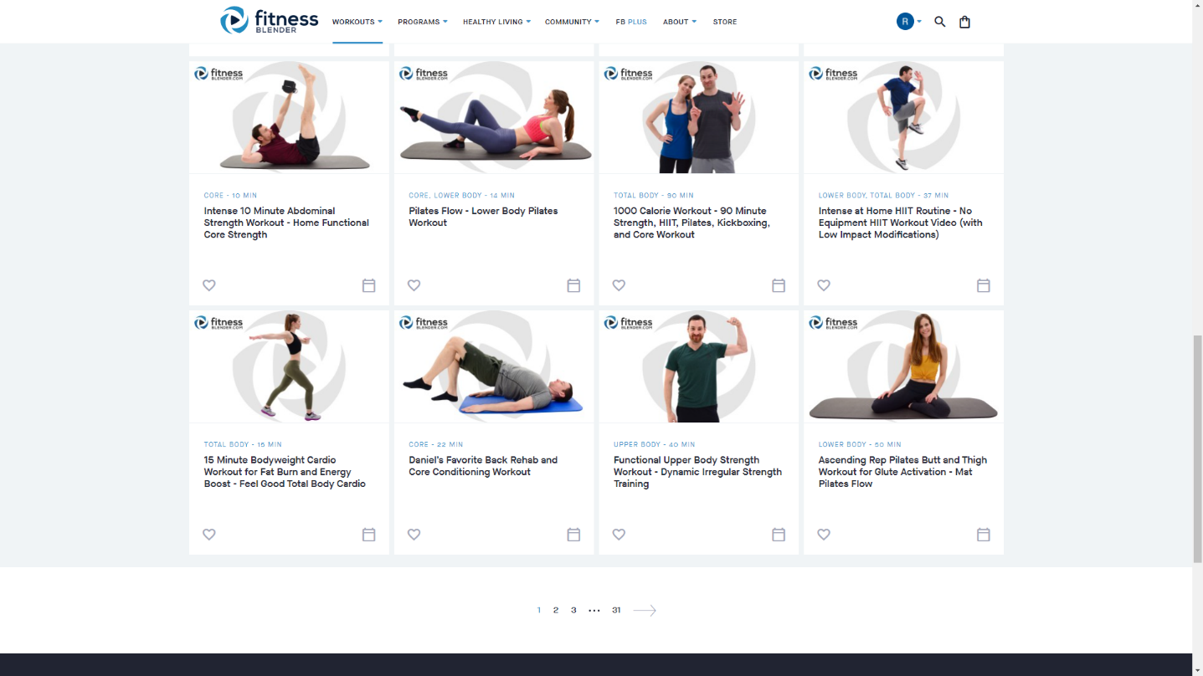

Figure .:Fitness Blender Home Page

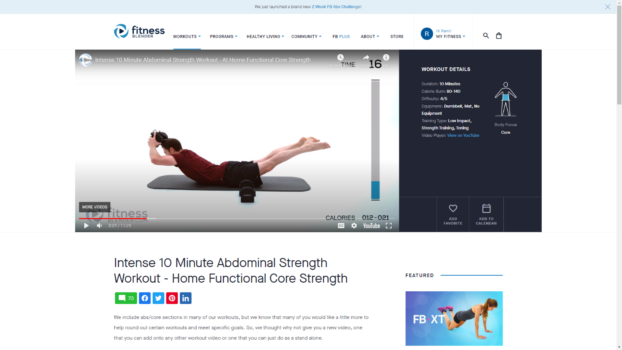

Figure .:Fitness Blender video page

### 1.4.2 BodyBuilding.com

Originally, BodyBuilding.com is an online retailer of dietary and sports supplement company.

However, recently, it has become a great resource for workout plans created by experts. It contains a huge database of workout videos that are updated regularly.

**Strong features**

Among its features, BodyBuilding.com offers:

Customizable fitness plans

Step-by-step workout guides

Community where users can interact with each other and share fitness-related information

New content regularly

**Drawbacks**

Even though BodyBuilding.com offers efficient and dynamic services. There are some weak points.

-It is mainly a shop, and its main interface is designed to promote supplement products and equipment.

-Most of their diets and workouts require users to buy supplements.

-Workout plans are offered to everyone that users have to choose the workout plans themselves.

-Most of their workouts require gym equipment.

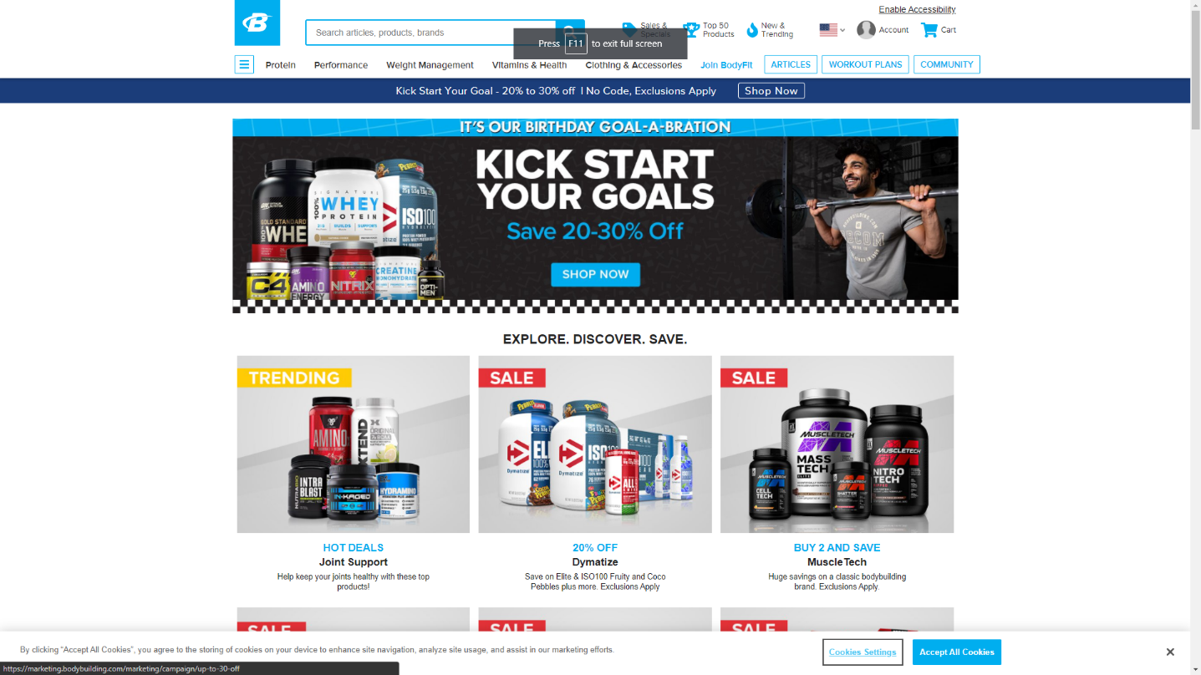

Figure .:Bodybuilding home page

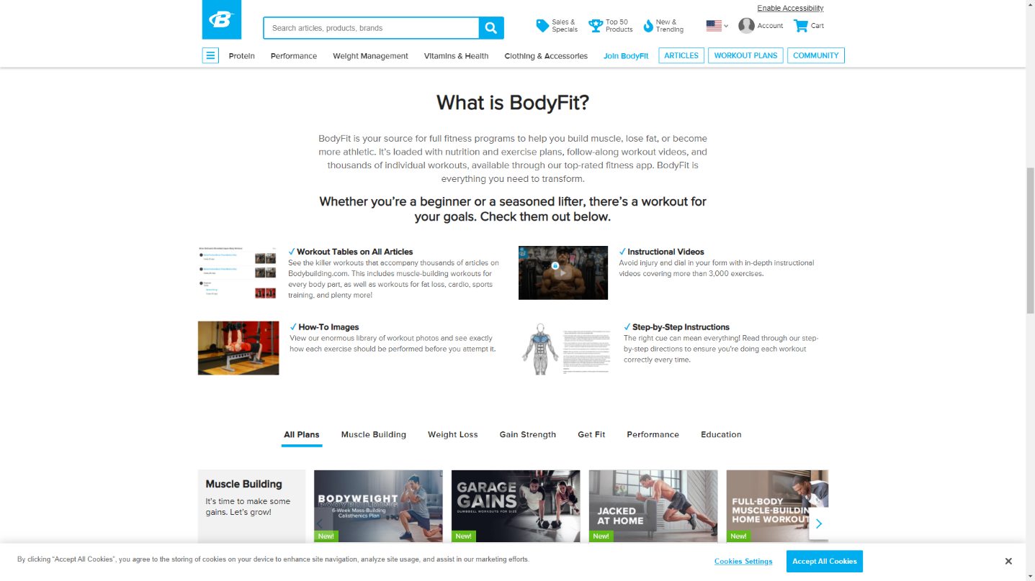

Figure .:Bodybuilding Body Fit page

In conclusion, Bodybuilding.com is a great source of workout plans and is not expensive, but the fact that it is a store for supplements and that it promotes supplements with workout can be confusing to its users.

1.4.3 6weeksixpack

A 6weeksixpack is a website that offers a challenge; after signing up, the user receives an email containing the link to the webpage that contains the workout for that day.

**Strong features**

- users receive daily emails that keep them motivated.

-Each webpage contains a video specific for one day and it is not sent twice

Drawbacks

-Users cannot see the entire program from the start; they have to wait until a specific day.

-The workouts are only about the abdominal muscles, not the entire body.

In conclusion, six 6packsixweek do not offer enough workout plans, nor do it connects users with each other, but the fact that users need to tune in each and every day to find out what needs to be done is a significant factor in helping participants to stick until the end of the program.

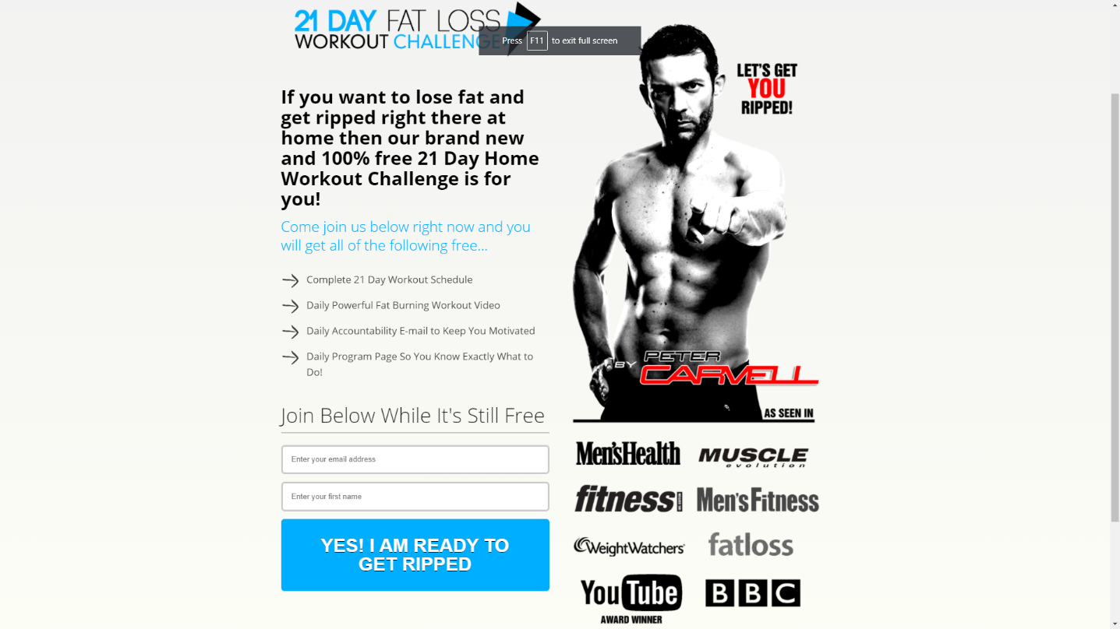

Figure .:weeksixpack Home Page

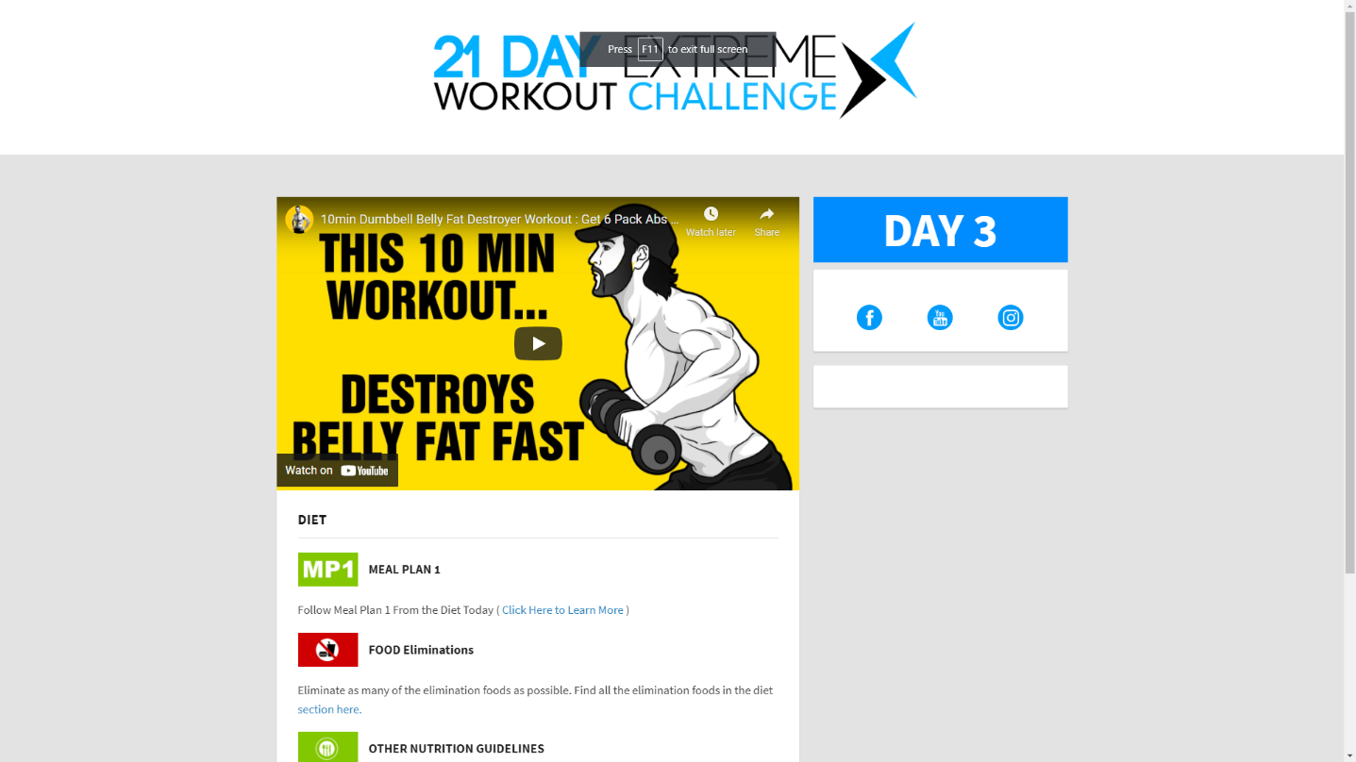

Figure .:sixweeksixpac Home Page

## 1.5 Criticism of the existing solutions

In this section, I will move on to the criticism of the existing solutions based on comparative research aimed at emphasizing the advantages of my application.

Even though they are all fitness applications that provide workout plans for its users, they differ in terms of several criteria, which are defined as follows:

* Design
* User experience
* Full-body workouts
* Home workouts
* Interaction between users
* Progress tracking
* Assigning workouts while considering their conditions
* Easy to use

Table 1.1 presents the results of a comparative study between the different solutions based on the criteria defined above.

|  |  |  |  |
| --- | --- | --- | --- |
|  | **Fitness blender** | **BodyBuilding.com** | **6weeksixpack** |
| **Design** | **V** | **x** | **x** |
| **User expericence** | **v** | **x** | **x** |
| **Full body workouts** | **v** | **v** | **x** |
| **Home workouts** | **v** | **v** | **v** |
| **Interaction between users** | **x** | **v** | **x** |
| **Progress Tracking** | **x** | **v** | **x** |
| **Assigning workouts for specific conditions** | **x** | **x** | **x** |
| **Easy to use** | **v** | **x** | **v** |

Table .:Comparison of Existing Apps and current project

## 1.6 Our solution

After the project study and research, we opted to create a web application that responded to its users in a way that the other existing ones never could.

-The fitness planet is going to be a dynamic and interactive web application that allows creating a fitness program and tracking users who are undergoing that program.

-Fitness planet is going to allow its user to receive a fitness program that meets their goals, and in the same time takes into consideration multiple factors like user’s age, gender and available time for workout.

-Every fitness program in Fitness Planet will contain all the required resources, such as videos and articles.

-It will also allow its users to connect with other users going through the same fitness program in support groups and to compete on top of the leaderboard. These groups will provide the motivation for users to stick to the program until the end.

-This solution will minimize the costs of hiring a personal trainer and help those who want to work out at home instead of going to the gym.

## 1.7 Methodologies

This methodology is a rationally organized approach to achieve results. Among the different existing methodologies, we find the waterfall approach, which is well known to be used in simple projects whose needs are clear and well defined from the beginning, Agile methodologies (scrum and extreme programming) characterized by their flexibility and used in large projects.

1.8.1 Waterfall Approach

The waterfall model is a linear project management approach in which stakeholder and customer requirements are gathered at the beginning of the project, and then a sequential project plan is created to accommodate those requirements. The waterfall model is so named because each phase of the project cascades into the next, following steadily down like a waterfall.

The waterfall model has at least five to seven phases that follow a strict linear order, where a phase cannot begin until the previous phase has been completed. The specific names of the phases vary, but they were originally defined by the inventor in the following way:

-**Requirements**: The key aspect of waterfall is that all customer requirements are gathered at the beginning of the project.

-**Design:** The requirement specifications from the first phase are studied in this phase, and the system design is prepared.

-**Implementation: With** inputs from the system design, the system is first developed in small programs called units, which are integrated in the next phase.

-**Integration and Testing:** All the units developed in the implementation phase are integrated into a system after testing each unit.

**-Deployment**: Once functional and non-functional testing is performed, the product is deployed in the customer environment or released into the market.

-**Maintenance:** The customer regularly uses the product during the maintenance phase, discovering bugs, inadequate features, and other errors that occur during production. The production team applies these fixes as necessary until the customer is satisfied.

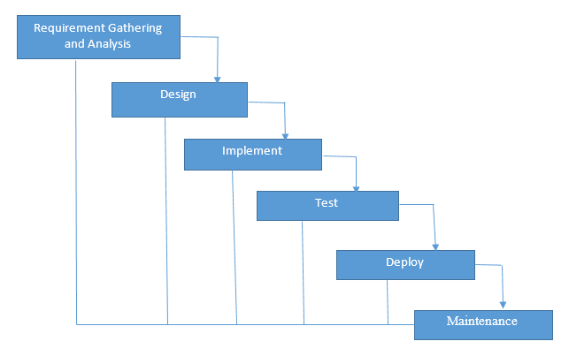

Figure .:Waterfall methodology diagram

1.8.2Scrum

Scrum is an agile development methodology used in the development of software based on iterative and incremental processes. Scrum is an adaptable, fast, flexible, and effective agile framework designed to deliver value to customers throughout the development of the project. The primary objective of scrum is to satisfy the customer’s needs through an environment starting from a general idea of what needs to be built, elaborating a list of characteristics ordered by priority (product backlog) that the owner of the product wants to obtain.

The framework is based on the division of a project in time boxed, called “sprints” Sprints can last from a few hours to a month (with a two-week preference). Each sprint begins with an estimate, followed by operational planning. The sprint ends with a demonstration of what has been completed.

The Scrum methodology is easily explained by the figure below.

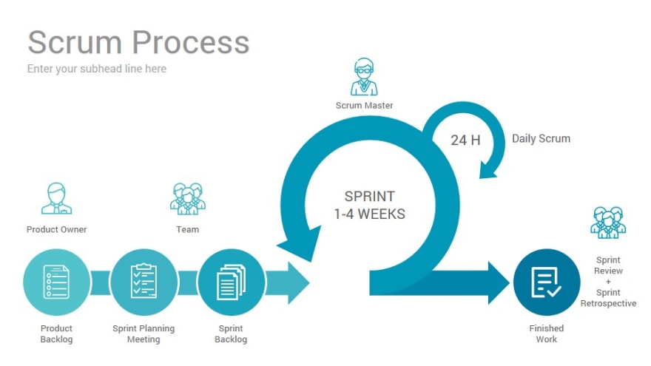

Figure .:Scrum Process Diagram

The basic principles of Scrum are the following:

Determining the functionalities needed to create the backlog of the product

-Defining the priorities of the functionalities and choosing which ones will be carried out in each iteration.

-Work on functionalities in iterations called sprint

-Each sprint always delivers a functional partial product called an increment.

**Scrum Roles**

* Product owner: This person is responsible for defining the work and prioritizing those tasks. They are clear on the goals of the project, as well as those of the customer market and organization.
* Scrum Master: He plays the role of a facilitator and guardian of the correct application. He is a product owner service. He facilitated interactions between members of the scrum team. He acts on the development process (development definitions of the duration of sprints, the agenda of scrum meetings ...)
* Development team: The development team is the heart of the scrum team, as it is responsible for doing the actual project work. Each member of the team has the skill that, together with other team members, combines to tackle all the needs of executing the project.

**Our choice**

We chose the scrum methodology as it is the closest methodology to how we planned our tasks and timelines.

1.9conclusion

In this chapter, we present the host company as well as the general context of the work, followed by a study of the existing solution that is close to our application, and we define our work methodology; and finally, we describe the different technologies used in this project.

# Specifications and Conceptions

2.1 Introduction

After presenting the general context of our project, we will dedicate this chapter to formally present our project. We will perform a detailed and complete analysis of different needs related to our application, which will include the following:

- specifying the functional and non-functional requirements of the proposed system

- Identification of the main actors interacting with our application.

-Presentation of global use case diagram

-presentation of different detailed use-case diagrams.

2.2 Functional requirements

In the following, we will present the functional requirements of our project.

Functional requirements express the actions that the system must execute in response to user requests. In our case, our application must satisfy the following requirements:

**Registration**

The application must allow users to register in order to access the application

**Authentication**

It allows the user to connect using his email address to benefit from the application’s features.

**Consulting workout**

It allows the user to open his account every day and check his workout for that day.

**Chat**

It allows the user to connect and chat with other users.

**Consulting support groups**

It allows the user to consult available support groups and to join them

**Creating support groups**

It allows the user to create support groups and invite people to these groups or make them public.

**Settings:**

It allows the use to consult or update settings

**Goal:**

It allows the user to consult or choose his goal.

**Creating workout**

It allows the admin to create a workout

**Consulting users**

It allows the admin to consult all the users

**Changing user’s workout**

It allows the admin to consult or change the user’s workout

2.3 Non-Functional requirements

We identify non-functional needs, which are operational constraints that affect the performance of the application. These are summarized as follows.

* **Scalability and maintenance**: The application must be able to adapt to any change on the implementation side (updating frameworks) to guarantee its evolution and flexibility. In addition,, it must offer a readable, understandable code, and modular.
* **Extensibility**: The system must be scalable and must consider the possibility of its extension by adding new features.
* **Security**: The Application must ensure the security of personal information
* **Performance**: The modules must optimize the treatments and reduce the execution time.
* **Ergonomics**: The application is user-friendly, simple to use, ergonomic, and adapted to the use
* **Reusability**: The components of the system can be reused for the development of different applications.
* **Modularity:** The application is well structured as modules to ensure better readability, a reduction in the risk of error, and the possibility of selective tests.

## 2.5 Identification of Actors

The actor is external to the system. It represents a person or other computer system waiting for one or more services offered by an interface access. It interacts with the system by sending or receiving messages.

The actors that will interact with the system are:

Administrator: This is the person who manages the entire application, which includes managing users and workouts.

User: He is the basic user who benefits from the features of the application.

2.4 Use-case diagrams

A use case diagram is a behavior diagram that visualizes the observable interactions between actors and the system under development. The diagram consists of the system, related use cases, and actors.

In this section, we present the needs of our system in a formal manner using unified modeling language (UML) use case diagrams. These features are described in the following diagrams.

### 2.4.1 Global use-case diagram:

The Figure describes, in a general way, the actors of the system as well as the functionalities. A detailed description of the different use cases will follow.

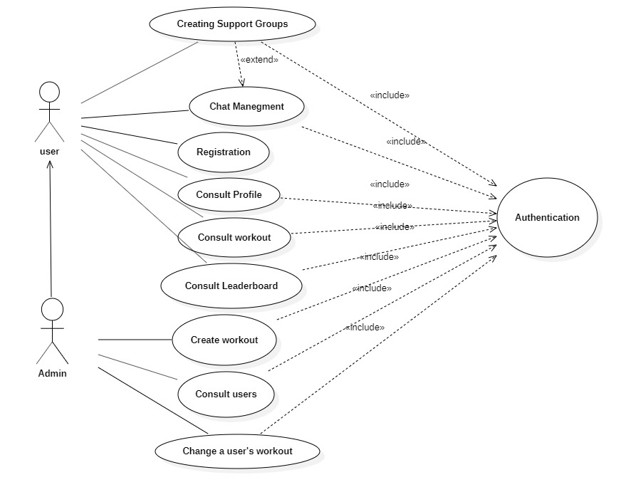

Figure .:General use case diagram

### 2.4.2 Authentication use-case diagram:

The figure represents the use-case diagram of authentication. The user will be able to have access to the application with his email and password, as well as restore access to the application through Restore Password Action in case of a forgotten password.

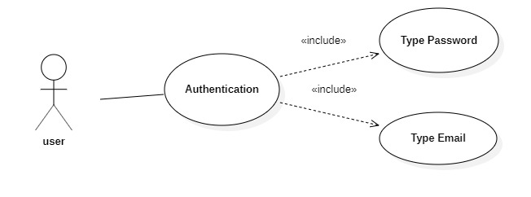

Figure .:Authentication use case diagram

Table 2.1 describes in details the authentication use case scenario:

|  |  |
| --- | --- |
| Actor | Admin, User |
| Objective | Get authenticated and access to the application’s features |
| Pre-condition | Registered email and password |
| Post condition | Redirection to Dashboard Page |
| Nominal Scenario | 1-User request the authentication interface  2- the application displays the interface  3-user fills in the necessary and valid fields  4-System checks the data entered and displays the dashboard Page |
| Alternative scenario | 1-User enters incorrect data  2-System displays an error message  3-Resumption of stage 3 of the nominal scenario |

Table .:Authentication use case scenario

2.4.3 Workout Management use-case diagram

Figure 2.3 represents the use case diagram of workout management: any user will be able to consult the workout page to see his exercises for that specific day. Admins I will be able to create, modify, or delete workouts.

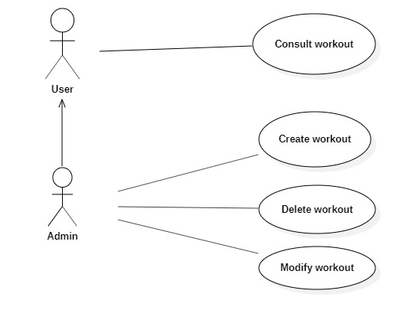

Figure .:Workout Management Use-Case Diagram

Table 2.4 describes in details the consult workout scenario:

|  |  |
| --- | --- |
| Actor | User |
| Objective | Consult Workout |
| Pre-condition | The user is authenticated |
| Pre-condition | The user has already chosen his goals and set his conditions |
| Post-condition | The user is shown the workout |
| Nominal Scenario | 1-User requests the Workout interface  2-System displays the interface  3-User retrieves his daily workout |
| Alternative scenario | 1-User requests the Workout  2-System displays the interface for choosing the goal  3-User sets the goal and conditions  3-Resumption of stage 2 of the nominal scenario |

Table .:Consult workout use case scenario

Table 2.5 describes in details the create workout scenario:

|  |  |
| --- | --- |
| Actor | Admin |
| Objective | Create a workout |
| Pre-condition | The admin needs to be authenticated |
| Post condition | The workout is saved and the admin is redirected to the interface containing the list of workouts with the new workout added |
| Nominal Scenario | 1-User request the create workout interface  2- the application displays the interface  3-user fills in the necessary and valid fields  4-System checks the data entered  5-The system saves the workout and resets the create workout interface’s fields. |
| Alternative scenario | 1-User enters already existent workout name  2-System displays an error message  3-Resumption of stage 3 of the nominal scenario |

Table .:Create workout use case Scenario

Table 2.6 describes in details the create workout scenario:

|  |  |
| --- | --- |
| Actor | Admin |
| Objective | Modify a workout |
| Pre-condition | The admin needs to be authenticated |
| Post condition | The modification is saved and the admin is redirected to the interface containing the list of workouts with the new workout added |
| Nominal Scenario | 1-User request the workout list interface  2- the application displays the interface  3-The user choses the workout to modify  3-user fills in the necessary and valid fields  4-System checks the data entered  5-The system saves the modification and redirect the user to the workout list interface |
| Alternative scenario | 1-User doesn’t enter the modification  2-User enter invalid information |

Table .:Modify workout use case scenario

Table 2.7 describes in details the delete workout scenario:

|  |  |
| --- | --- |
| Actor | Admin |
| Objective | Delete a workout |
| Pre-condition | The admin needs to be authenticated |
| Post condition | The workout is deleted and the admin is redirected to the interface containing the list of workouts without the workout that got deleted |
| Nominal Scenario | 1-User request the create workout interface  2- the application displays the interface  3-User choose the workout to be deleted  5-The system deletes the workout and the admin is redirected to the interface containing the list of workouts without the workout that got deleted |
| Alternative scenario | 1-User doesn’t delete the workout |

Table .:Delete Workout use case scenario

2.4.4 Chat Management use case Diagram

Figure 2.4 shows the use case diagram of chat management. After authentication, the user can look up and start a conversation with him and create a group chat with multiple users, which serves as a support group.

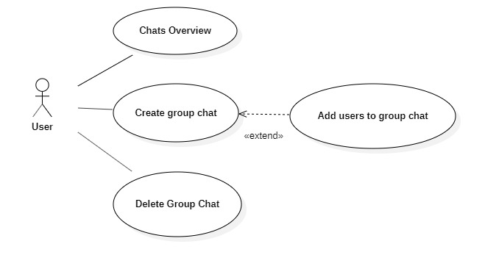

Figure .:Chats Management Use Case Diagram

Table 2.8 describes in details the chats overview scenario:

|  |  |
| --- | --- |
| Actor | User |
| Objective | Consult Chats |
| Pre-condition | The user is authenticated |
| Pre-condition | The user has already chosen his goals and set his conditions |
| Post-condition | The user is shown the list of chats |
| Nominal Scenario | 1-User requests the chats interface  2-System displays the interface |
| Alternative scenario | 1-User didn’t start any chat  2-The user is redirected to an empty chats interface |

Table .:Consult Chats Use Case Scenario

Table 2.9 describes in details the Create Group Chat Scenario:

|  |  |
| --- | --- |
| Actor | User, Admin |
| Objective | Start new chat |
| Pre-condition | The user needs to be authenticated |
| Post condition | The user can send messages to the other user in the chat |
| Nominal Scenario | 1-User request the chats interface  2- the application displays the interface  3-user fills in the name of the user  4-System shows users with relative name  5-User choose who he wants to start a conversation with  5-The system create the conversation and the user is redirected to the conversation interface |
| Alternative scenario | 1-User enters a wrong username  2-System doesn’t display any users  3-User enters the correct username  3-Resumption of stage 4 of the nominal scenario |

Table .:Start New Chat use case Scenario

Table 2.9 describes in details the create group chat scenario:

|  |  |
| --- | --- |
| Actor | Admin |
| Objective | Create new group chat |
| Pre-condition | The user needs to be authenticated |
| Post condition | The group chat is saved and the users within it can chat with each other |
| Nominal Scenario | 1-User request the group chat interface  2- the application displays the interface  3-user fills in the group chat name field  4-System creates the chat group |
| Alternative scenario | 1-User enters already existent group chat name |

Table .::Create New Group Chat use case Scenario

Table 2.91 describes in details the add users to group chat scenario:

|  |  |
| --- | --- |
| Actor | Admin |
| Objective | Add users to group chat |
| Pre-condition | The user needs to be authenticated |
| Pre-condition | The group chat is already created |
| Post condition | The users are added to the group chat |
| Nominal Scenario | 1-User chooses the group chat  2- The user requests the add users’ interface  3-System displays the add users interface  4-Users enter the name of the users to add  5-The users are added to the group chat |
| Alternative scenario | 1-User enters inexistant user name  2-System doesn’t show any user  3-Resumption of stage 4 of the nominal scenario |

Table .:Add Users to Group Chat use case Scenario

## Conclusion

Throughout this chapter, we presented the functional and non-functional needs related to our application, as well as the main functionalities such as workout and chat management, and in the end, we presented the different use-case diagrams and scenarios of those functionalities.

# Design and architecture

3.1 Introduction

The design and architecture are two of the most important building blocks because proper project understanding is necessary from the outset. In this chapter, we will elaborate on the global architecture of the project and present conceptual aspects by providing different diagrams, such as sequence and class diagrams.

3.2 Design Pattern

Design patterns are solutions to general problems faced by software developers during software development. These solutions were obtained by trial and error by numerous software developers over a substantial period of time.

### 3.2.1 MVC MERN Stack

MVC is a design pattern that represents a model view controller that separates the application into three components (layers), which aims to isolate the logic of the application from the presentation layer, as well as prohibiting direct access to the data stored by these layers.

In our project, we used the MERN stack, which stands for MongoDB, Express, React, and Node, after the four key technologies that make up the stack.

The structure of our project is described as follows:

**Model**

Central component of the pattern It is the dynamic data structure of the application, independent of the user interface.[[5]](https://en.wikipedia.org/wiki/Model–view–controller#cite_note-5) It manages the data, logic, and rules of the application.

In our project, the MongoDB modals represent how data are stored in the mongoDB database.

**View**

The view is a visual representation of the data, such as charts, diagrams, tables, and forms.

The view contains all functionalities that directly interact with the user, such as clicking a button or an enter event.

In our project, the presentation part is implemented in React.js in the format of the components.

**Controller**.

The controller connects the model and view. The controller converts inputs from the viewpoint of the demands to retrieve/update data in the model.

The controller receives input from view, uses logic to translate the input to a demand for the model, the model grabs the data, and the controller passes data from the model back to the view for the user to see in a nice display.

In our project, it is a JavaScript file that contains the required logic to manipulate the data coming from the database and to handle requests given by the Express.js router.

See figure 3.1,3.2 and 3.3

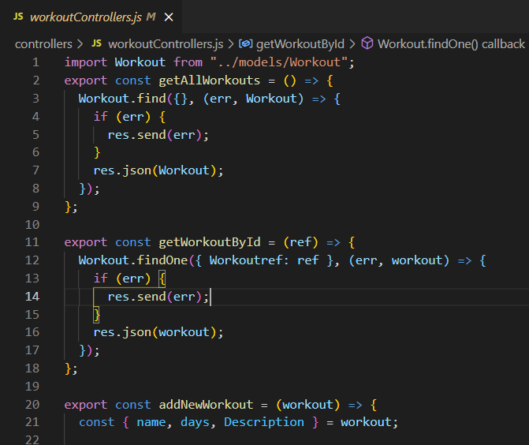 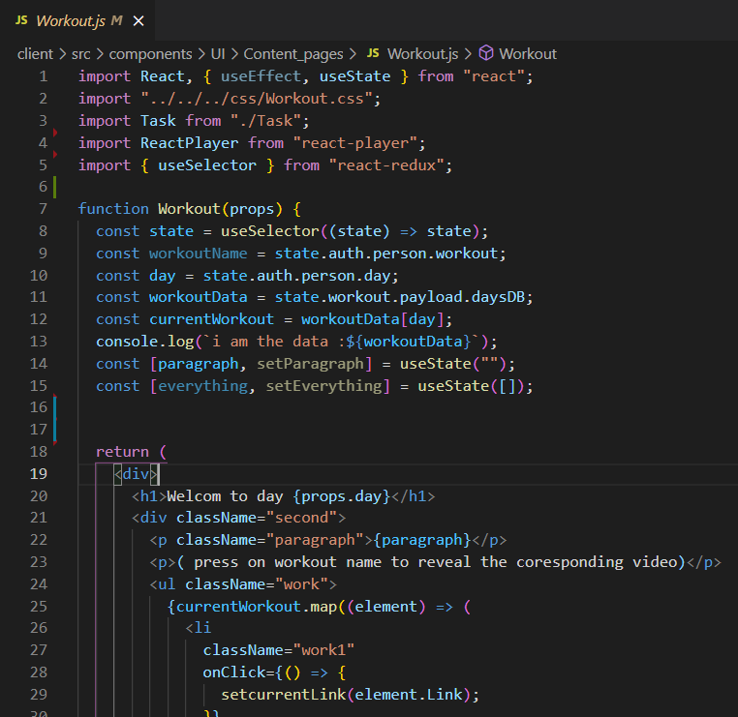

Figure .:The Controller Figure .:The View

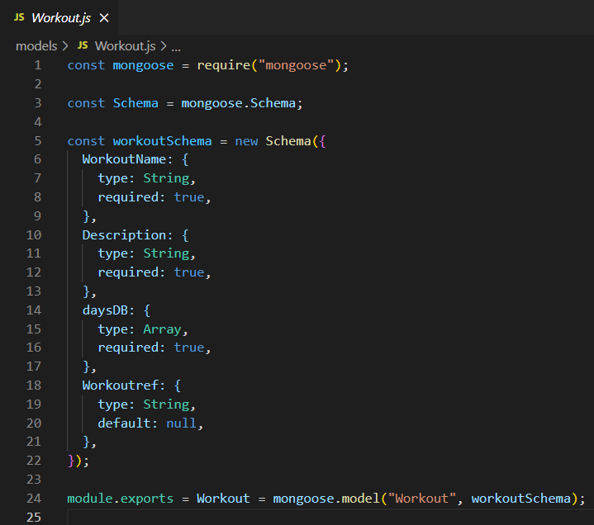

:

Figure .:The model

### 3.2.2 MVC Flow

The user interacts with the UI, and the controller is notified via this view. Based on user interaction, the controller modifies certain models. The models perform some business logic and return the updated model data state to the controller. The controller can then update the UI according to the new data state as received from the model.

The figure 3.1 describes MVC flow:

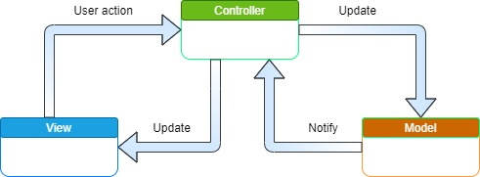

Figure .:MVC flow

3.3 Physical Architecture

During the development of our project, we chose the three-tier architecture because it is a well-established software application architecture that organizes applications into three logical and physical computing tiers: the presentation tier, the user interface, the application tier, and the data tier (see figure 3.2).

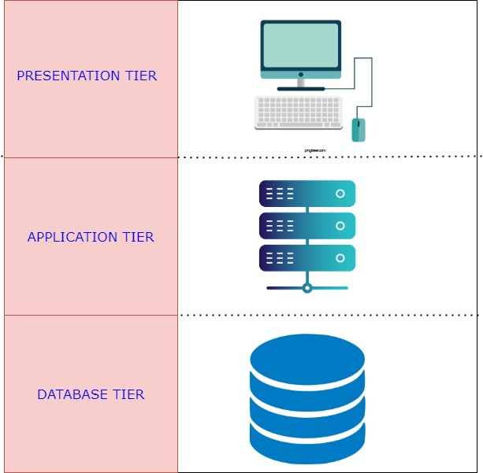

Figure .:Physical Architecture

Client Tier: the user interface and communication layer of the application, where the end user interacts with it. Its main purpose is to display information and collect information from the user.

Application Tier, also known as the logic tier or middle tier, is the heart of the application. In this tier, information collected in the presentation tier is sometimes processed-against other information in the data tier-using business logic, a specific set of business rules. The application tier can also add, delete, or modify data in the data tier.

Data Tier:

Sometimes called a database tier, data access tier, or back-end, is where the information processed by the application is stored and managed.

Benefits of three-tier architecture:

**Separation**: The chief benefit of the three-tier architecture is that because each tier runs on its own infrastructure, each tier can be developed simultaneously by a separate development team, and can be updated or scaled as needed without impacting the other tiers.

-**Faster development**: Because each tier can be developed simultaneously by different teams, an organization can bring the application to the market faster, and programmers can use the latest and best languages and tools for each tier.

**Improved scalability**: Any tier can be scaled independently of the others as needed.

**Improved reliability**: An outage in one tier is less likely to impact the availability or performance of other tiers.

**Improved security**: Because the presentation and data tiers cannot communicate directly, a well-designed application tier can function as a sort of internal firewall, preventing SQL injections and other malicious exploits.

## 3.4 Deployment Diagram

A deployment diagram in the unified modeling language (UML) models the physical deployment of artifacts on nodes. To describe a web site, for example, a deployment diagram would show what hardware components exist, what software components run on each node, and how the different pieces are connected (see Figure 3.3).

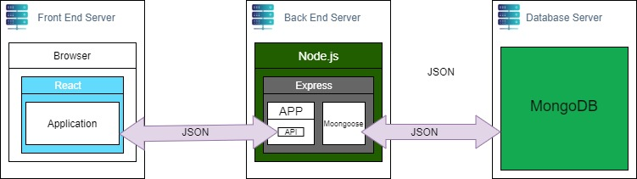

Figure .:Deployment Diagram

## 3.5 Logical Architecture

Choosing an architecture for an application is a paramount step in the process of making the application before moving on to the project design.

Our web application is composed of three parts: front-end, back-end, and database. The Front-End is realized with React.js Framework combined with Redux library (React-Redux) for state management and Axios, which uses the Rest APIs implemented in the back-end, in which we used Express.js.

Figure 3.4 represent our application’s software architecture:

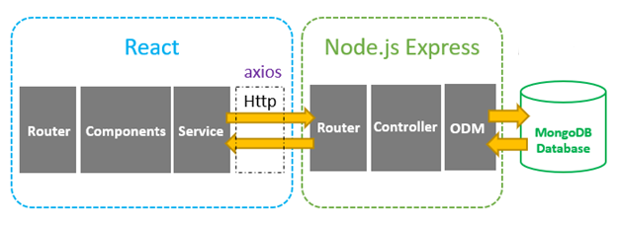

Figure .:Logical Architecture Diagram

Express communicates with the MongoDB database (NoSQL database) using mongoose. Everything in the database has a representation in the form of manipulable objects called models to simplify access and operations performed on the database, which is represented by mongoose ODM.

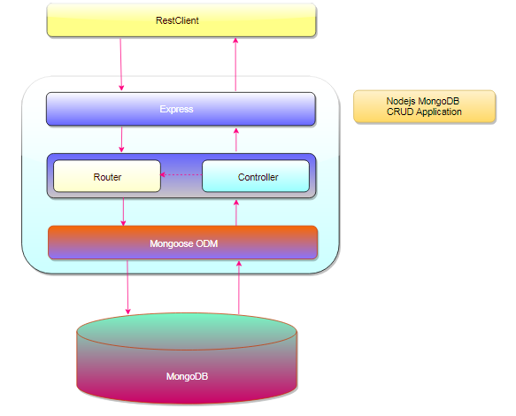

Figure .:BackEnd diagram

In this way, every collection in the MongoDB is represented by a modal, and the express controller contains the logic concerning the actions performed by the user that affect those collections.

For the front-end, we used Redux to define how the state of the component was managed.

Redux is a library that acts as a state container and helps to manage the application data flow, providing a central place for storing data that is used across the React application.

The concepts of Redux is better explained in the figure 3.6:

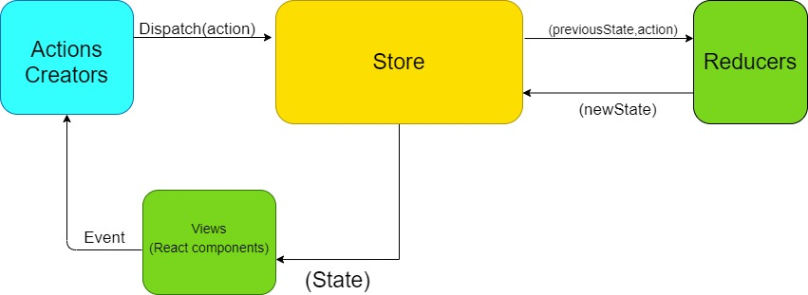

Figure .:Redux diagram

**Actions**: they are JavaScript objects that contain to properties “type” and “payload.”

**Actions Creators**: These are functions that dispatch actions after a reaction component fires an even.

**-Store**: An immutable object tree in Redux. A store is a state container that holds the state of the application.

**-Views:** The views are the React component, which can be created to depend on the state that the store holds.

**-Reducer**s: It is a pure function that takes an action and the previous state of the application and returns the new state. The action describes what happened, and it is the reducer’s job to return the new state based on that action.

In our project we created a chat service through which the user can communicate with other users, we used the mongoDB to save the messages, and we used socket.io, which means when a user receives a message, his conversation refreshes automatically and sees the new message without having to refresh the page.

The socket.io communicated the react directly without passing through the Express.js server.

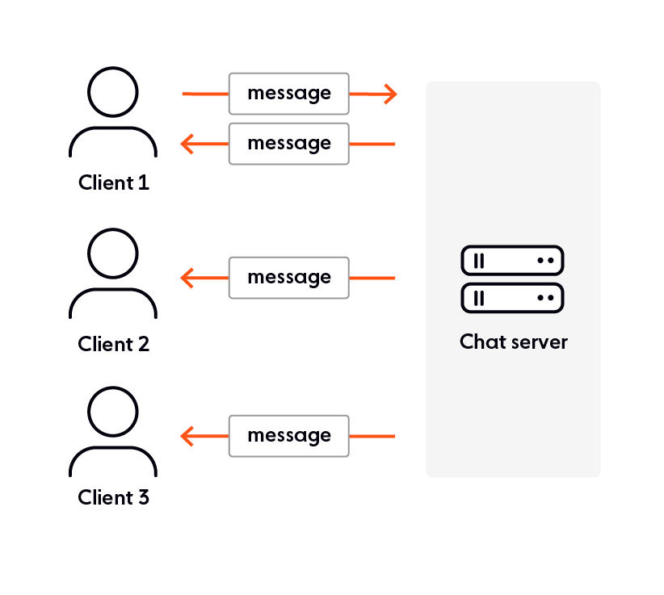

Figure .:Socket.io Diagram

## 3.6 Sequence diagrams

In this section, we present the dynamic views of the system using sequence diagrams for the most important functionalities in our application.

Sequence diagrams are interaction diagrams that detail how operations are performed. They capture the interactions between objects in the context of collaboration. Sequence diagrams are time focused, and they show the order of the interaction visually by using the vertical axis of the diagram to represent the time at which messages are sent and when.

### 3.5.1 Authentication Sequence Diagram

This authentication sequence diagram describes how the user can connect to the application and exploit its features. Authentication is successful only if the user has already registered and enters the right credentials.

If the user has not registered or entered incorrect data, he/she gets notified by an error message. Otherwise, the system verifies his credentials in the database and then returns a token containing his information, which will be saved in local storage; then, the user is redirected to the dashboard.

Figure 3.6 illustrated the sequence diagram of the Authentication scenario:

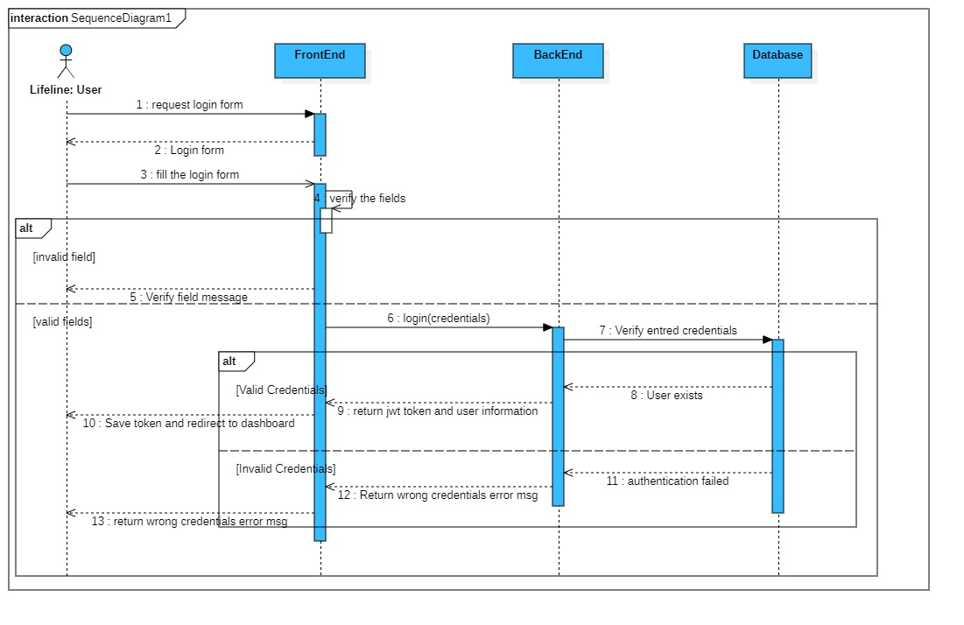

Figure .:Authentication Sequence Diagram

### 3.5.1 User Management Sequence Diagram

Use case user management allows the admin to consult the list of users as well as promote any user to admin or delete them. If these operations are successful, the system displays a successful message.

If there’s no users, the system displays an empty list.

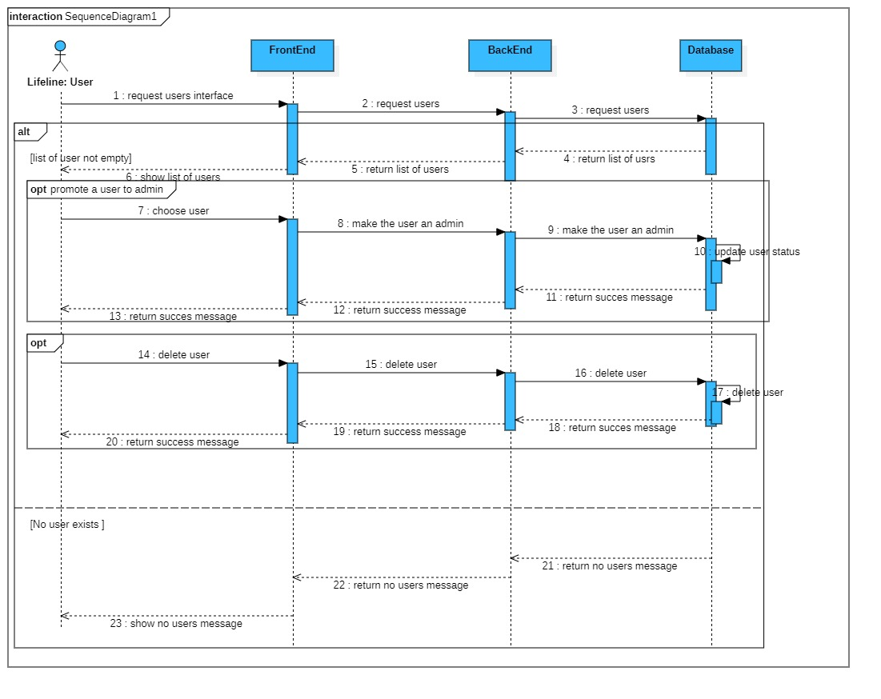

Figure .:User Management Sequence Diagram

### 3.5.1 New Chat Sequence Diagram

The new chat use case allows a user to start a new conversation with any other user. The operation is only performed if both users are already registered.

If the user inserts a user name that does not exist, the system returns an error message to check the name field; otherwise, it creates a new conversation and redirects the user to that conversation.

Figure 3.7 represents the sequence diagram of the New Chat scenario:

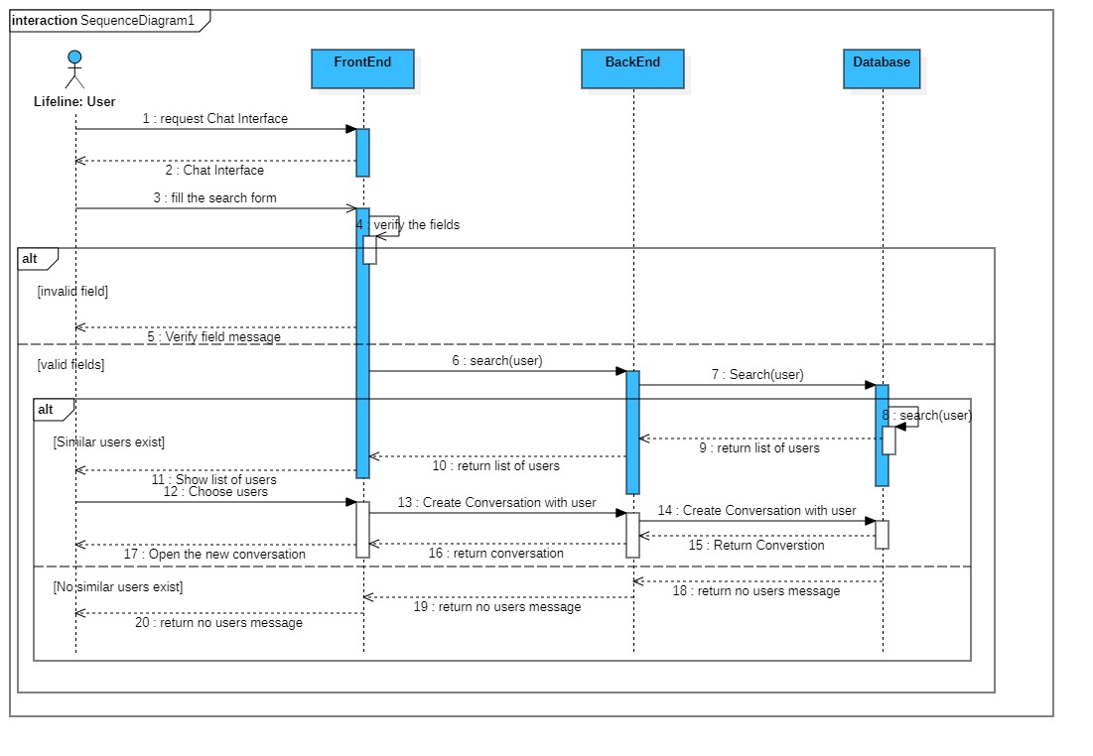

Figure .:Create New Conversation Sequence Diagram

## 3.6 General Class Diagram

The class diagram is the main building block for object-oriented modeling. It is used for general conceptual modeling of the structure of the application and for detailed modeling, translating the models into a programming code. Class diagrams can also be used for data modeling.

Because our project follows the MVC design pattern, we shaped the class diagram accordingly.

Figure 3.8 represents the general class diagram of the application:

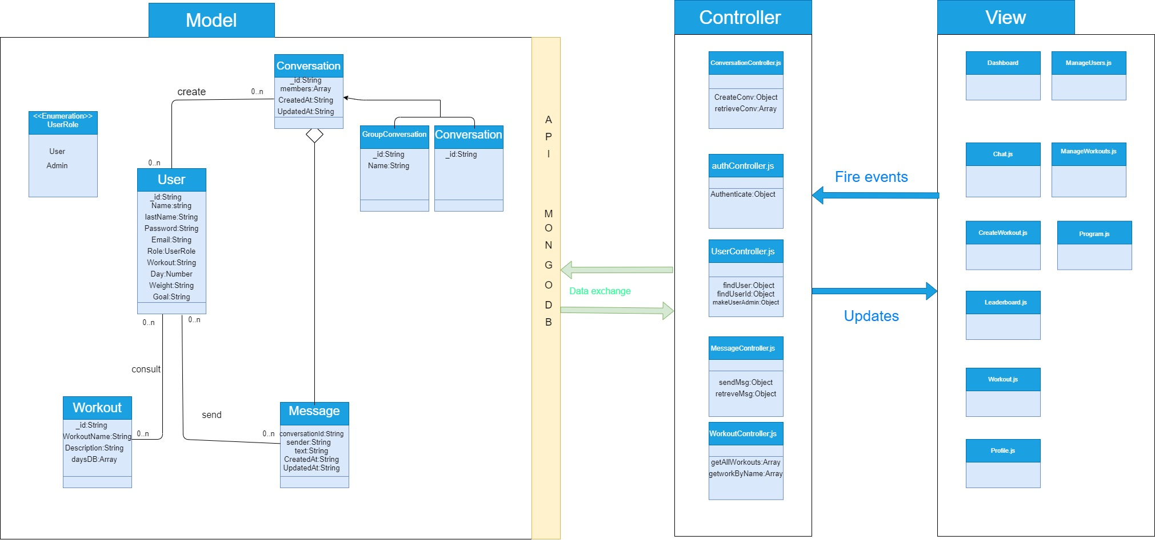

Figure .:General Class Diagram

## 3.7 Gantt Diagram

The Gantt diagram is commonly used in project management. It allows representation of the state of progress over time of the different activities (sprints in our case) constituting a project visually. The column on the left lists the tasks to be performed, while the columns on the right represent the time units. Each task was materialized by a horizontal bar, whose position and length represented the start date, duration, and end date.

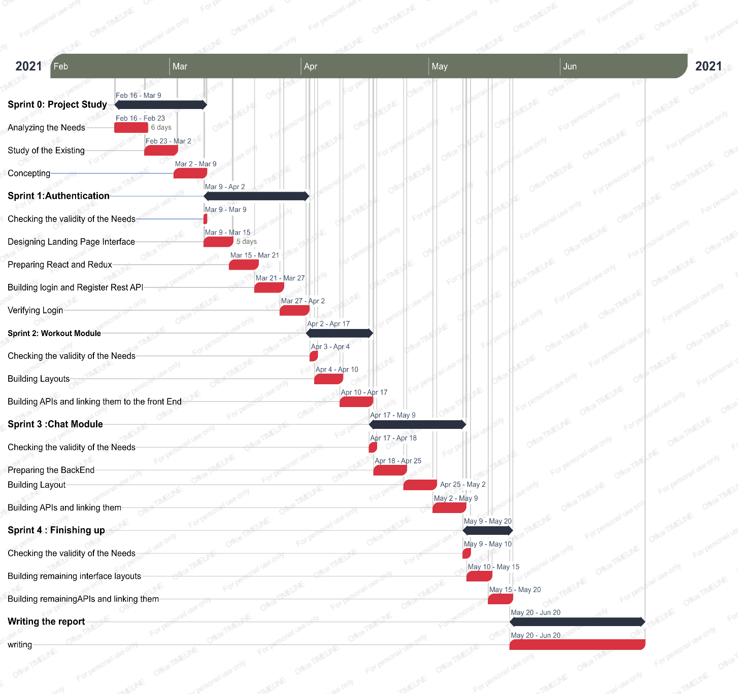

Figure .:Gantt Diagram

## 3.8 Conclusion

In this chapter, we presented the design pattern that we followed, as well as the physical and logical architecture, and then moved on to present a different sequence diagram, followed by the general class diagram and the Gantt diagram.

# : Realization

4.1 Introduction

In every craftsmanship, the quality of the tools plays a decisive role in the quality of the product, and it is the same in software development. This is why the choice of programming tools needs to be made after an in-depth study of these tools.

After presenting the conceptual aspects of our project in the last chapter, we present the realization of our project after we present the tools that helped us bring our idea to life.

## 4.2 Working environment and tools

In this section we will present the software and hardware environment

### 4.2.1 Material Environment

During this project, we used a laptop characterized by the following:

* OS: Windows 10
* CPU:1.70GHz Intel Core i5 four cores
* RAM: 8Go
* Hard Disk: 1000GO HDD.

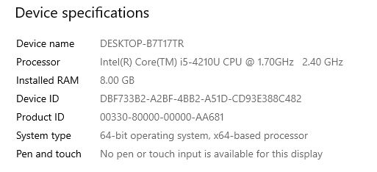

Figure .:Computer characteristics

### 4.2.2 Software Environment

In this section, I will present the technologies chosen for my project:

**Front-End**

**React.js** is an open-source, front-end JavaScript library for building user interfaces or UI components. It is maintained by Facebook and a community of developers and companies.

Component-Based

React allows its users to build encapsulated components that manage their own state and then compose them to create complex UIs.

Declarative

React makes it painless to create an interactive UI. After designing simple views for each state in the application, React efficiently updates and renders just the right components when the date changes.

Write once, Use everywhere

React components are easily re-usable in different applications.



Figure .:ReactJS logo

Redux

Redux is an [open-source](https://en.wikipedia.org/wiki/Open-source_software) [JavaScript library](https://en.wikipedia.org/wiki/JavaScript_library)  that manages the application [state](https://en.wikipedia.org/wiki/State_(computer_science)). It is most commonly used with libraries such as [React](https://en.wikipedia.org/wiki/React_(web_framework)) or [Angular](https://en.wikipedia.org/wiki/Angular_(web_framework)) for building [user interfaces](https://en.wikipedia.org/wiki/User_interface). Similar to (and inspired by) Facebook's [Flux architecture](https://en.wikipedia.org/wiki/React_(JavaScript_library)#Unidirectional_data_flow), it was created by Dan Abramov and Andrew Clark.



Figure .:Redux Logo

Bootstrap

**Bootstrap** is a [free and open-source](https://en.wikipedia.org/wiki/Free_and_open-source) [CSS framework](https://en.wikipedia.org/wiki/CSS_framework) directed at responsive, [mobile-first](https://en.wikipedia.org/wiki/Responsive_web_design#Mobile_first,_unobtrusive_JavaScript,_and_progressive_enhancement) [front-end web development](https://en.wikipedia.org/wiki/Front-end_web_development). It contains [CSS](https://en.wikipedia.org/wiki/CSS)- and (optionally) [JavaScript](https://en.wikipedia.org/wiki/JavaScript)-based design templates for [typography](https://en.wikipedia.org/wiki/Web_design#Typography), [forms](https://en.wikipedia.org/wiki/Form_(HTML)), [buttons](https://en.wikipedia.org/wiki/Button_(computing)#HTML), [navigation](https://en.wikipedia.org/wiki/Web_navigation#Local_website_navigation), and other interface components.

As of April 2021, Bootstrap is the tenth most starred project on [GitHub](https://en.wikipedia.org/wiki/GitHub)



Figure .:Bootstrap Logo

**Reactstrap**

**Reactstrap** is a component library for the reactors. It provides inbuilt bootstrap components that make it easy to create UI with its self-contained components that provide flexibility and inbuilt validations. Reactstrap is similar to Bootstrap, but it has self-contained components. It is easy to use and supports Bootstrap 4.



Figure .:Reactstrap Logo

**Back-End**

**Node.js**

Node.js is an open-source, cross-platform, back-end JavaScript runtime environment that runs on the V8 engine and executes JavaScript code outside a web browser, allowing developers to use JavaScript to write command line tools and server-side scripting-running scripts server-side to produce dynamic web page content before the page is sent to the user’s web browser.

Node.js represents a “JavaScript everywhere ‘paradigm, unifying web-application development around a single programming language, rather than different languages for server-side and client-side scripts.



Figure .:Node.js Logo

**Express.js**

**Express.js**, or simply Express, is a  [back-end](https://en.wikipedia.org/wiki/Front_end_and_back_end" \o "MEAN (software bundle))  [web application framework](https://en.wikipedia.org/wiki/Web_application_framework) for [Node.js](https://en.wikipedia.org/wiki/Node.js), released as [free and open-source software](https://en.wikipedia.org/wiki/Free_and_open-source_software) under the [MIT license](https://en.wikipedia.org/wiki/MIT_License" \o "MIT License). It is designed to build  [web applications](https://en.wikipedia.org/wiki/Web_application) and [APIs](https://en.wikipedia.org/wiki/API).[[3]](https://en.wikipedia.org/wiki/Express.js#cite_note-ExpressJS-3) It has been called the [de facto standard](https://en.wikipedia.org/wiki/De_facto_standard) server framework for [Node.js](https://en.wikipedia.org/wiki/Node.js).[[4]](https://en.wikipedia.org/wiki/Express.js#cite_note-4)



Figure .:Express.js logo

**MongoDB**

The MongoDB is a source-available cross-platform document-oriented database program. Classified as NoSQL database programming uses JSON-like documents with optional schemes.



Figure .:MongoDB logo

Socket.io

**Socket.IO** is a [JavaScript](https://en.wikipedia.org/wiki/JavaScript) library for real-time  [web applications](https://en.wikipedia.org/wiki/Web_application). It enables real-time, bidirectional communication between web clients and servers. It has two parts: a [client-side](https://en.wikipedia.org/wiki/Client-side) library that runs in the [browser](https://en.wikipedia.org/wiki/Web_browser), and a [server-side](https://en.wikipedia.org/wiki/Server-side) library for [Node.js](https://en.wikipedia.org/wiki/Node.js). Both components had nearly identical  [APIs](https://en.wikipedia.org/wiki/Application_programming_interface" \o "Application programming interface). Like [Node.js](https://en.wikipedia.org/wiki/Node.js), it is [event-driven](https://en.wikipedia.org/wiki/Event-driven_architecture).



Figure .:Socket.io Logo

Visual Studio Code

**Visual Studio Code** is a [source-code editor](https://en.wikipedia.org/wiki/Source-code_editor) made by [Microsoft](https://en.wikipedia.org/wiki/Microsoft) for [Windows](https://en.wikipedia.org/wiki/Windows), [Linux](https://en.wikipedia.org/wiki/Linux) and [macOS](https://en.wikipedia.org/wiki/MacOS).[[9]](https://en.wikipedia.org/wiki/Visual_Studio_Code#cite_note-TechCrunch-9) Features include support for [debugging](https://en.wikipedia.org/wiki/Debugging), [syntax highlighting](https://en.wikipedia.org/wiki/Syntax_highlighting), [intelligent code completion](https://en.wikipedia.org/wiki/Intelligent_code_completion), [snippets](https://en.wikipedia.org/wiki/Snippet_(programming)), [code refactoring](https://en.wikipedia.org/wiki/Code_refactoring), and embedded [Git](https://en.wikipedia.org/wiki/Git). Users can change the [theme](https://en.wikipedia.org/wiki/Theme_(computing)), [keyboard shortcuts](https://en.wikipedia.org/wiki/Keyboard_shortcut), preferences, and install [extensions](https://en.wikipedia.org/wiki/Plug-in_(computing)) that add additional functionality.



Figure .:Visual Studio Code Logo

StarUml

StarUML is a UML tool developed by MKLab. The software was licensed under a modified version of GNU GPL until 2014, when a rewritten version 2.0.0 was released for beta testing under a proprietary license. After being abandoned for some time, the project had a revival to move from Delphi to Java/Eclipse and then stopped again.



Figure .:StarUML Logo

**Draw.io**

diagrams.net (formerly **draw**.**io**) is a free online diagram software. It can be used as a flowchart maker and network diagram software to create UML online, as an ER diagram tool, to design database schema, to build BPMN online, as a circuit diagram maker, and more. **draw**.**io** can import. vsdx, Gliffy™, and Lucidchart™ files



Figure .:draw.io Logo

Git

**Git** is software for tracking changes in any set of [files](https://en.wikipedia.org/wiki/Computer_file), and is usually used for coordinating work among [programmers](https://en.wikipedia.org/wiki/Programmer) collaboratively developing [source code](https://en.wikipedia.org/wiki/Source_code) during [software development](https://en.wikipedia.org/wiki/Software_development). Its goals include speed and support for distributed, non-linear workflows (thousands of parallel branches running on different systems).



Figure .:Git Logo

Postman

**Postman** is an interactive and automatic tool for verifying the APIs of a project. **Postman** is a desktop application for interacting with HTTP APIs. It presents you with a friendly GUI for constructing requests and reading responses. It **works** on the backend and ensures that each API **is working** as intended



Figure .:Postman Logo

**Microsoft Word**

**Microsoft Word** is a [word processor](https://en.wikipedia.org/wiki/Word_processor) developed by [Microsoft](https://en.wikipedia.org/wiki/Microsoft). It was first released on October 25, 1983[[6]](https://en.wikipedia.org/wiki/Microsoft_Word#cite_note-6) under the name *Multi-Tool Word* for [Xenix](https://en.wikipedia.org/wiki/Xenix" \o "Xenix) systems. Subsequent versions were later written for several other platforms .



Figure .:Microsoft Word Logo

## 4.3 Implementation

In this section, we present the accomplished work in our application by presenting screenshots of the main interfaces.

### 4.3.1 Home Interface

The home interface provides a general presentation of the application, content, and features. Figure 4.15 represents the home page:

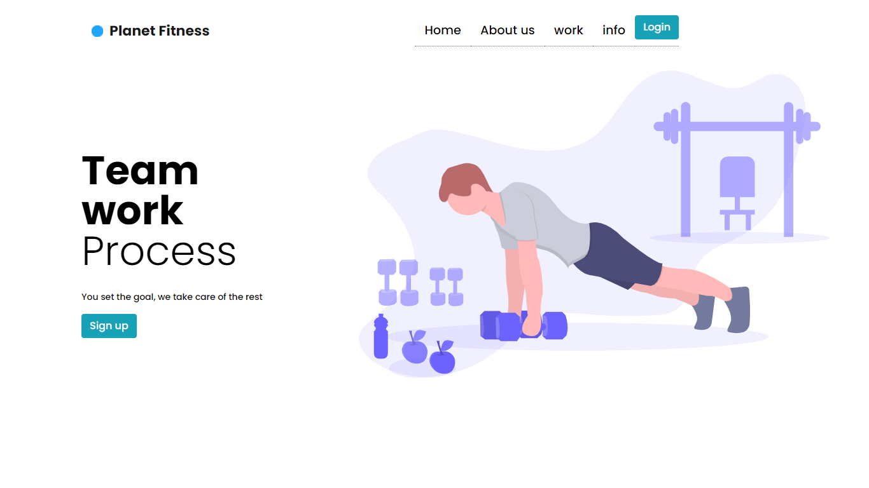

Figure .:Home page

### 4.3.2 Registration interface

The registration interface allows the user to create an account to gain access to its features. Figure 3.16 shows the registration interface.

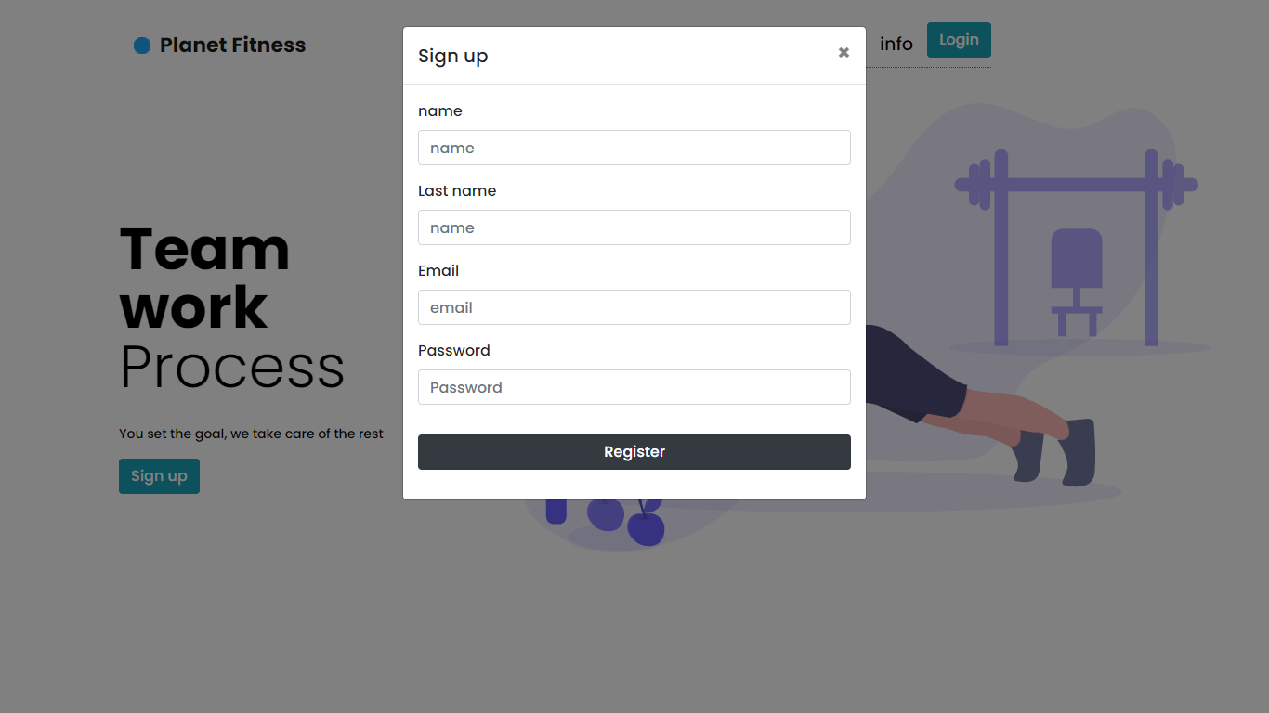

Figure .:Registration Interface

### 4.3.3 Login Interface

The login interface allows the user to gain access to the system after the successful validation of his credentials. Figure 4.17 shows the login interface.

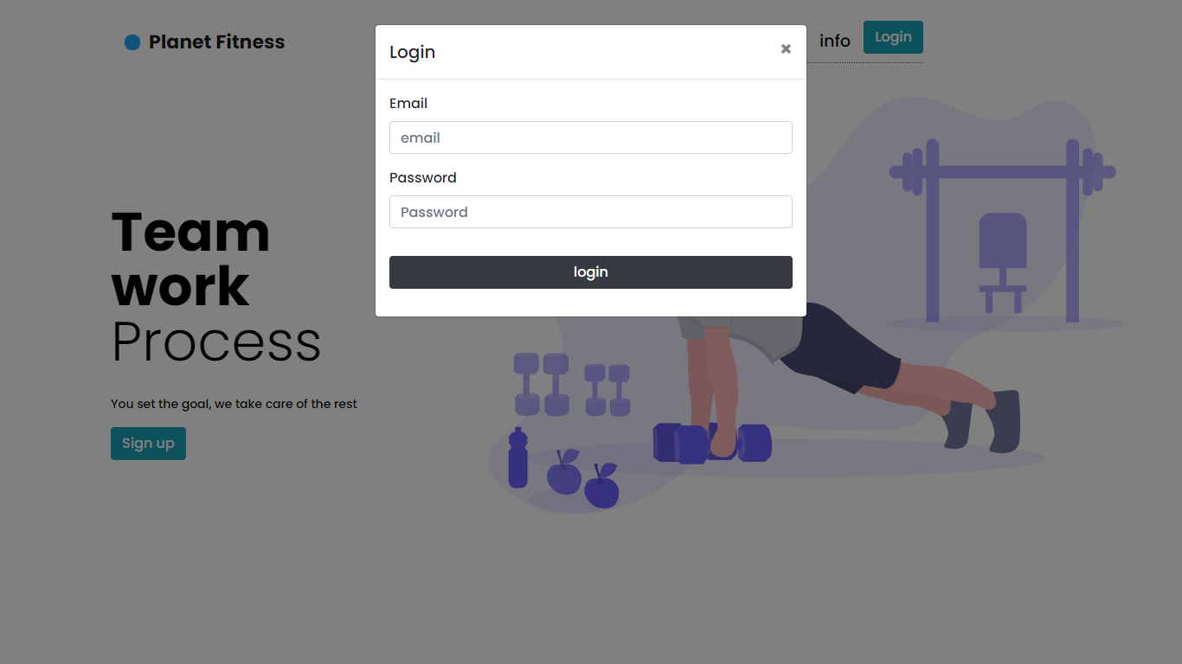

Figure .:Login interface

### 4.3.4 Admin Dashboard interface

Figure 4.18 represents the admin dashboard, which gives the admin more functionalities than the normal user.

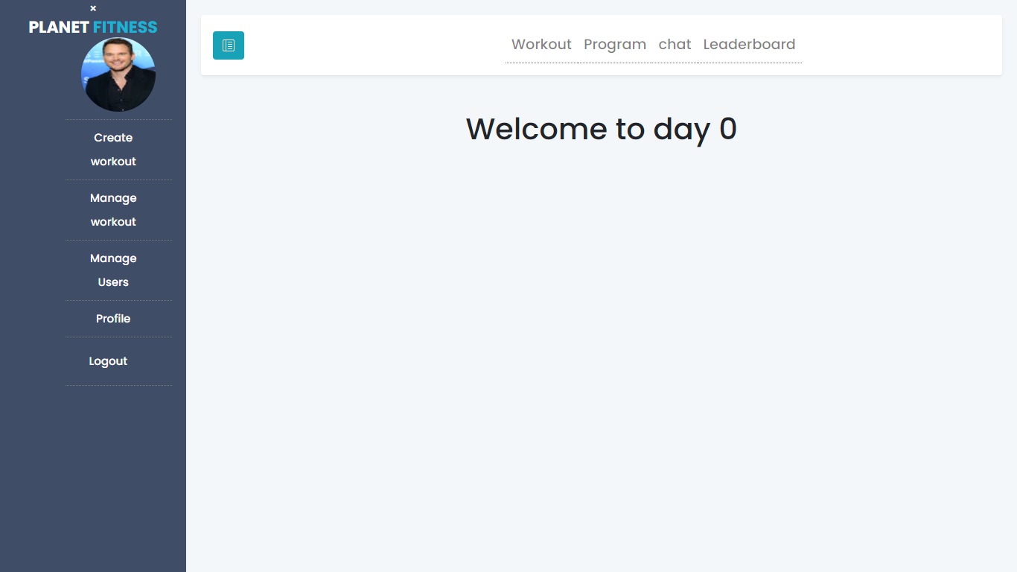

Figure .:Admin Dashboard

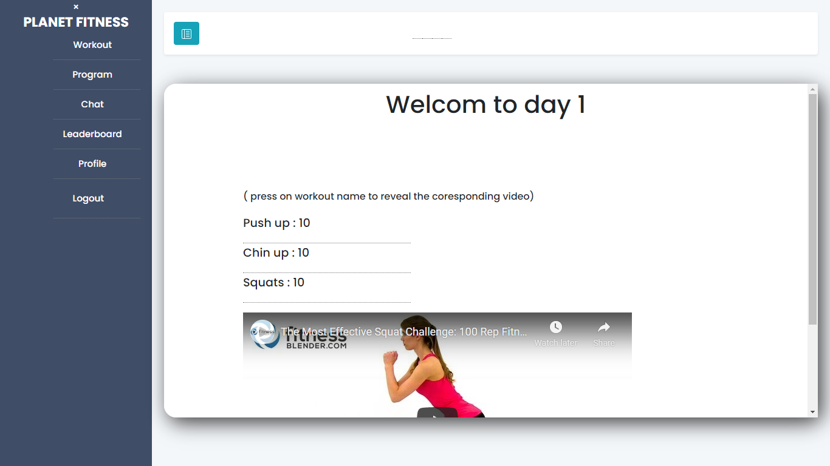

Figure .:User Dashboard

### 4.3.5 Create workout interface

The created workout interface permits the user to fill the required fields, after which he can press the submit button so that the workout is saved in the database. Figure 4.19 and 4.20 represent the created workout interface.

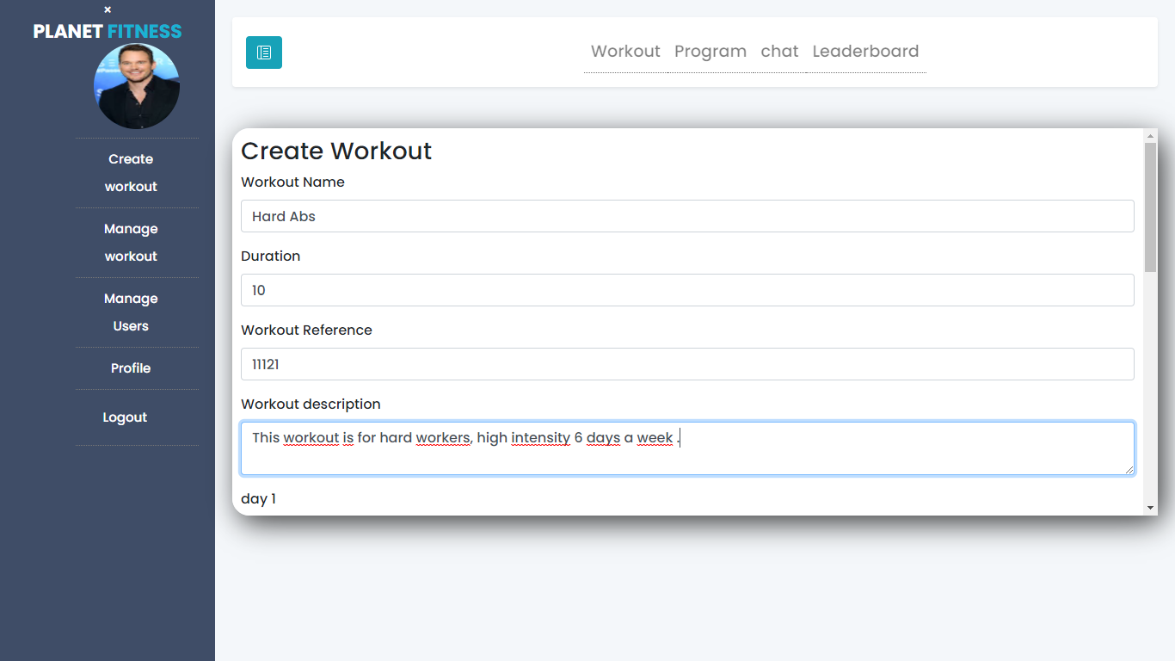

Figure .:Create workout 1

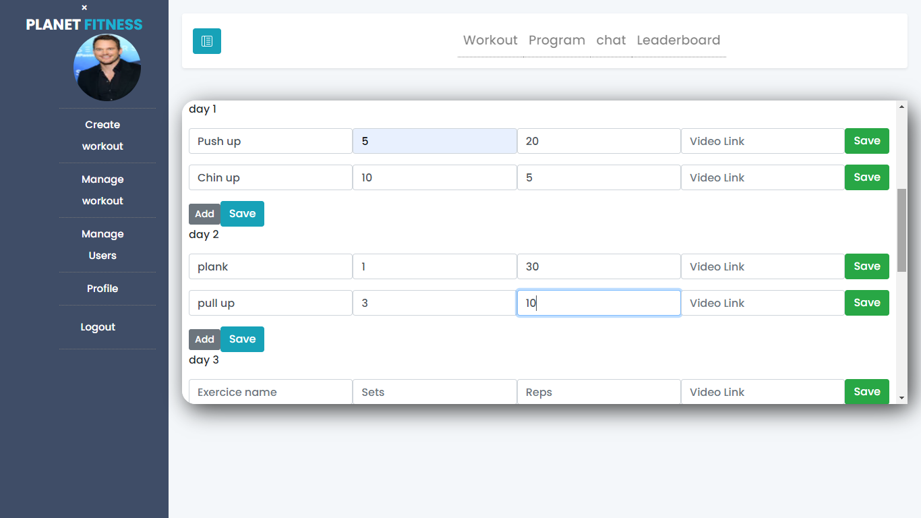

Figure .:Create Workout 2

### 4.3.6 Manage Workout Interface

Figure 4.3.6 represents the Manage Workout Interface, which allows the admin to consult all the workouts and delete anyone he chooses.

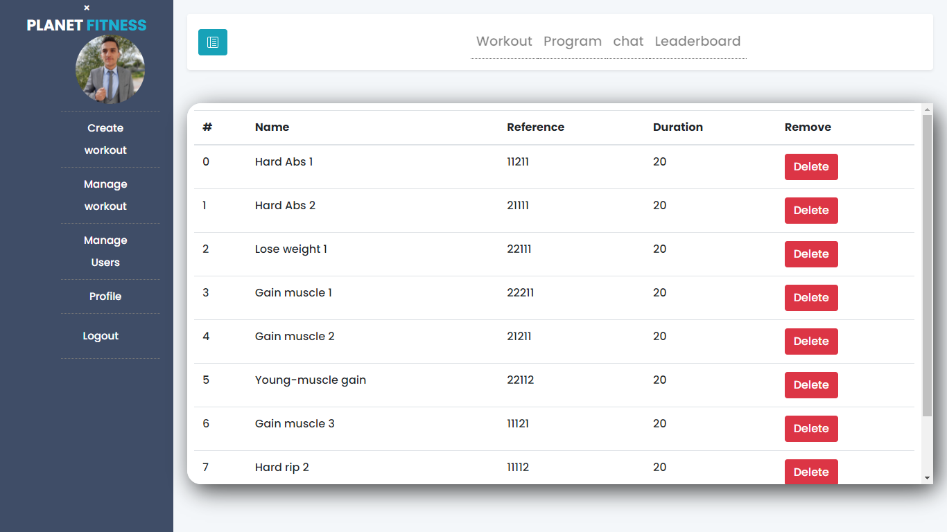

Figure .:The Manage Workout Interface

### 4.3.7 Manage Workout Interface

Figure 4.3.7 represents the Manage Users Interface, which allows the admin to consult all the users and delete anyone he chooses.

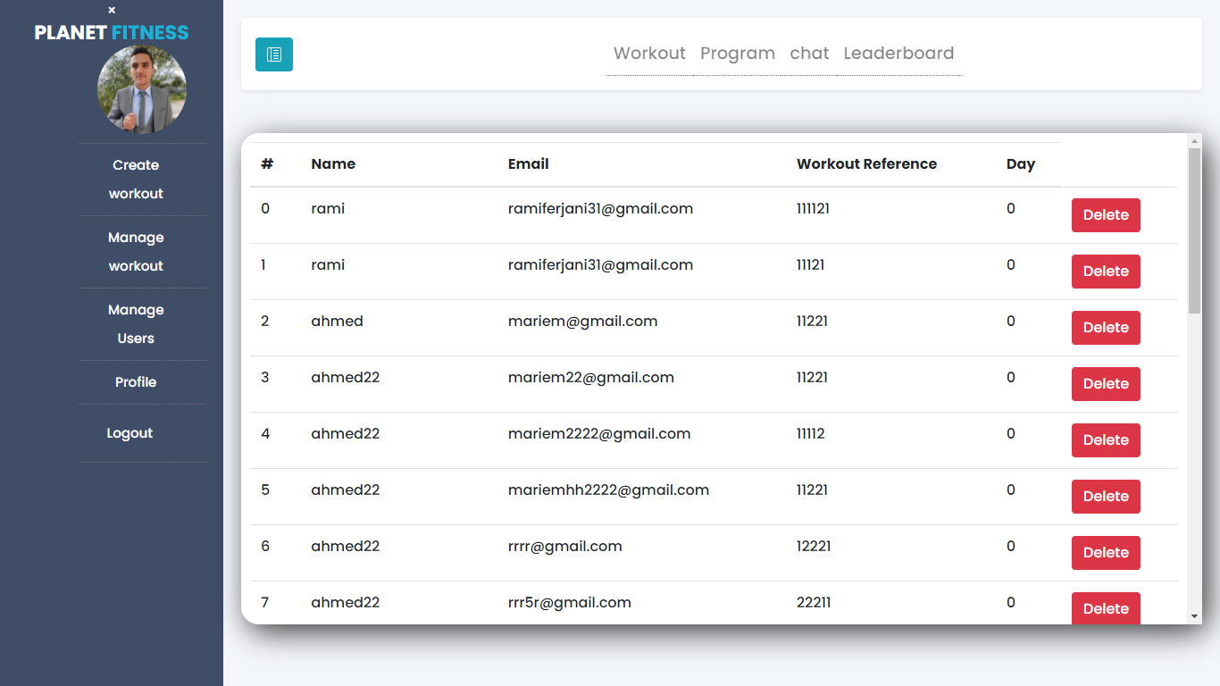

Figure .:Manage Users Interface

### 4.3.8 Chat Interface

Figure 4.3.8 represents the Chat Interface, where the user can type the name of the user he wants to chat with, the interface shows a list of users with similar names, and the user then clicks on the user he chooses.

s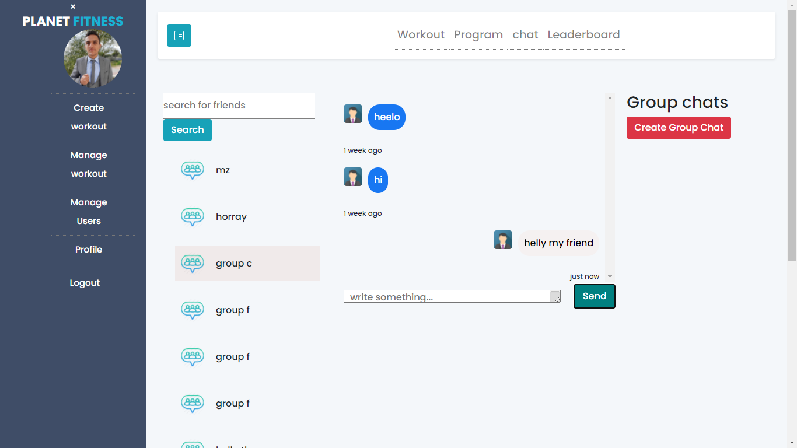

Figure .:Chat Interface

### 4.3.8 Create Group Chat Interface

Figure 4.24 represents the Create Group Chat Interface, where the user chooses the name of the group chat, and then adds the users and submits.

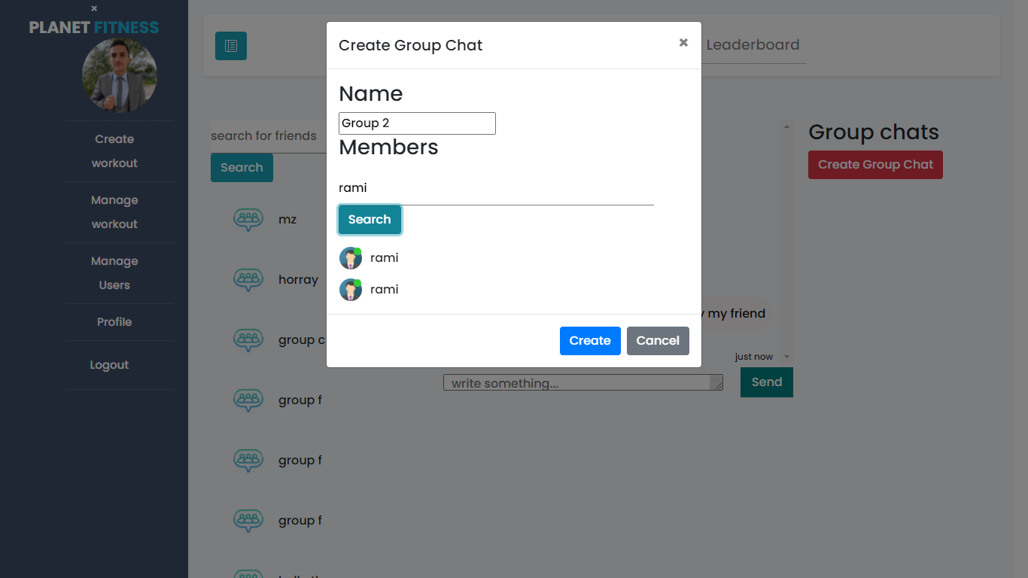

Figure .:Create Group Chat Interface

### 4.3.8 Leaderboard Interface

Figure 4.25 represents the leaderboard interface; any user or admin can check the leaderboard, which contains the list of all users ordered by the points earned by completing each day’s workout.

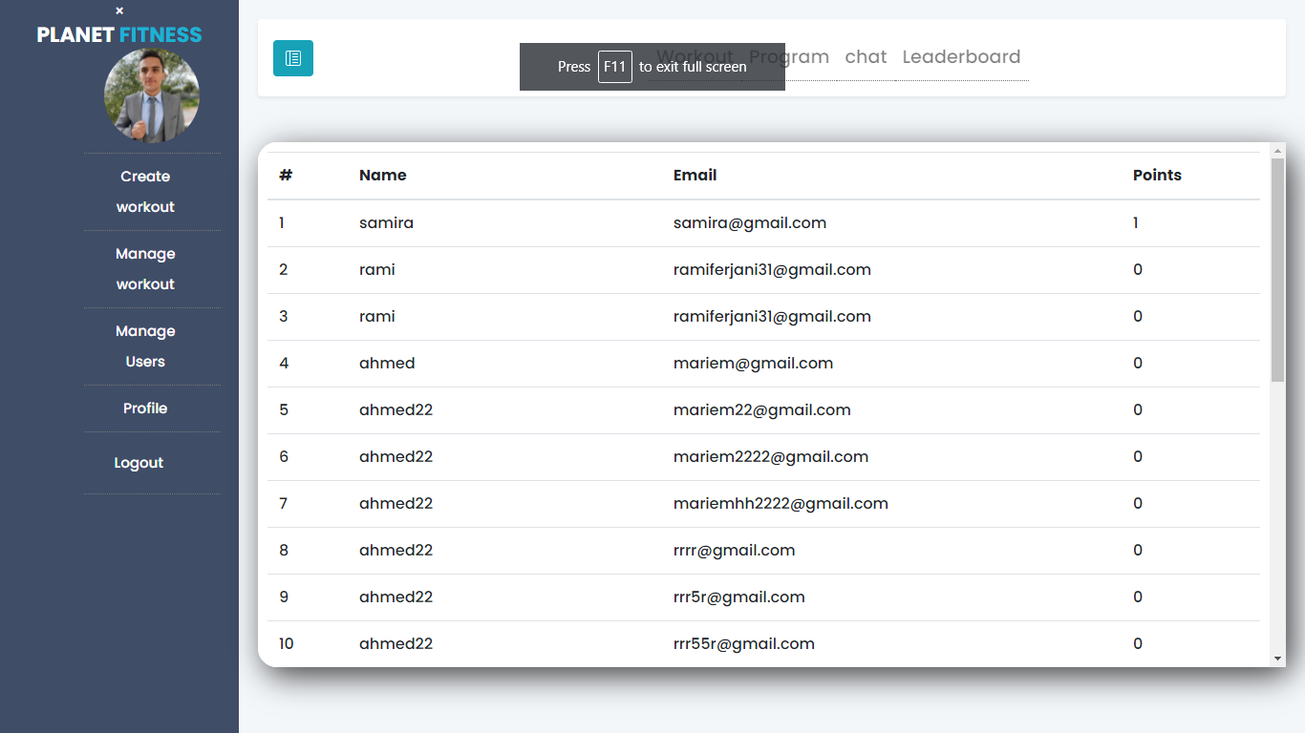

Figure .:Leaderboard Interface

### 4.3.9 Profile Interface

Figure 4.26 represents the profile interface; the user can modify the profile pictures and information using this interface.

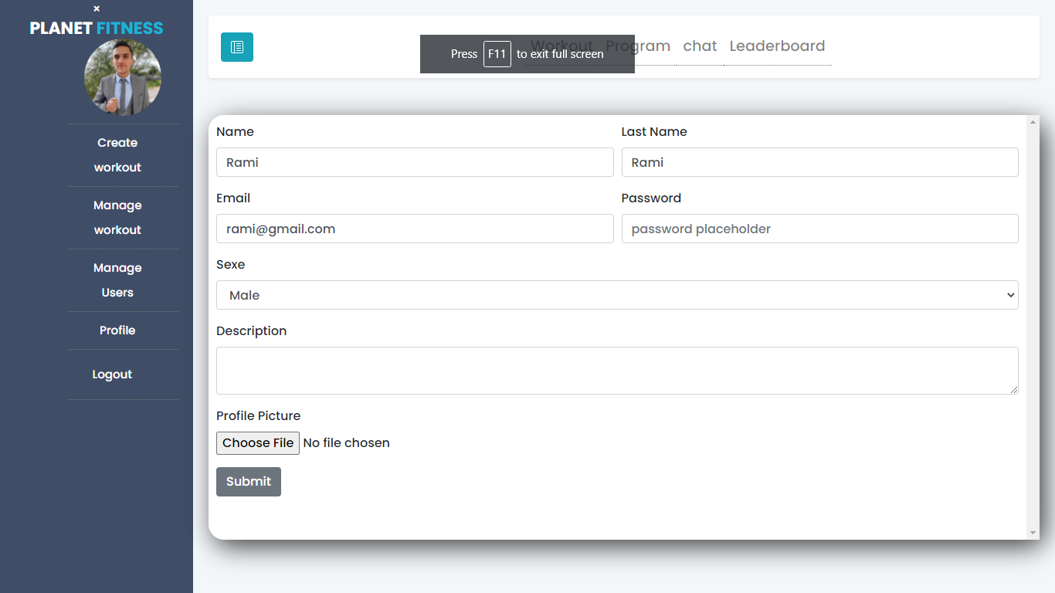

Figure .::Profile Interface

## Conclusion

In this chapter, we describe the development environment in which we developed our application, as well as the frameworks used. This is followed by an overview of the work carried out through screenshots of the application’s interfaces.

## General conclusion and perspectives

The period of internship in Mega-DEV was quite rewarding for me. As future software developers, this internship has allowed me to learn new technologies, methodologies, and working environments.

The main objective of the project is to create a workout management system based on the requirements and specifications developed by Mega-DEV. The solution englobes different features, such as workout management, chat …

The benefits of this work go beyond the programming knowledge as per the use of modern technologies such as React.js and Express.js frameworks; in fact, the agile project management approach used is a topnotch methodology that allowed us to ensure that bugs were fixed in due time and waves were tailored through every iteration.

Even though the achieved result satisfies the requirements, there is room for improvement, such as adding a mobile version of the application, and adding more interactions between the users.

Among the different lessons picked up during this work, is how to plan ahead and manage time effectively to achieve the tasks before the deadlines.

## Webography

1. Three tier architecture. Accessed 2021-05-15 https://www.ibm.com/cloud/learn/three-tier-architecture
2. Visual Studio Code: Accessed 2020-06-11. URL: https://en.wikipedia.org/wiki/Visual_Studio_Code
3. Redux: Accessed 2021-04-30.URL: https://en.wikipedia.org/wiki/Redux_(JavaScript_library)
4. Redux: Accessed 2021-04-30. URL: https://en.wikipedia.org/wiki/Bootstrap_(front-end_framework)
5. Reactstrap. Accessed 2021-02-30. url: https://www.c-sharpcorner.com/article/reactstrap-in-reactjs/
6. Express.js: Accessed 2021-03-22. URL: https://en.wikipedia.org/wiki/Express.js
7. StarUML: Accessed 2021-04-05. URL: https://en.wikipedia.org/wiki/StarUML
8. Draw.io: Accessed 2021-04-12. URL: https://app.diagrams.net/
9. Git: Accessed 2021-05-30. URL: https://en.wikipedia.org/wiki/Git
10. Redux: Accessed 2021-06-12. URL: <https://www.axelerant.com/resources/team-blog/api-testing-with-postman>
11. Agile methodology: Accessed 2021-02-25. ://en.wikipedia.org/wiki/Agile_software_development.
12. React Design pattern Accessed 2021-03-18: <https://www.educative.io/blog/react-design-patterns-best-practices>
13. Socket.io Accessed:2021-04-15https://en.wikipedia.org/wiki/Socket.IO